Mündliche Prüfung im letzten Jahr der Sekundarstufe I – Englisch
– Orientierung am Referenzniveau A2 mit Anteilen von B1 –
Jobs
Das Prüfungsbeispiel Jobs wurde als Paarprüfung konzipiert. Es basiert auf dem in den Kernlehrplänen Sekundarstufe I für die Hauptschule (hier Kurs Typ A: Orientierung am Referenzniveau A2 mit Anteilen von B1) sowie für die Gesamtschule (G-Kurs: Orientierung am Referenzniveau A2 mit Anteilen von B1) ausgewiesenen Themenfeld Berufsorientierung des soziokulturellen Orientierungswissens und fokussiert auf die Beschreibung unterschiedlicher Berufe sowie die Auseinandersetzung über verschiedene inhaltliche Aspekte, die mit den jeweiligen Berufsbildern einhergehen.
Mit den aufgeführten Aufgabenstellungen können zwölf Prüflinge (= sechs Paarprüfungen) geprüft werden. Die Aufgabenstellung für den ersten Prüfungsteil Sprechen: zusammenhängendes Sprechen ist für alle Aufgaben gleich. Die folgende tabellarische Aufstellung enthält die jeweiligen Berufe sowie die Aufgabenstellung.
Comparing jobs
- gardener – childcare assistant
- cook – car mechanic
- baker – postman
- hairdresser – plumber
Tasks:
- Describe the two photos in detail. What kinds of jobs are presented here?
- Choose the job that you would prefer to do and explain why.

Die Aufgabenstellungen für den zweiten Prüfungsteil Sprechen: an Gesprächen teilnehmen stehen unter demselben thematischen Dach Jobs. Es werden role cards zu den folgenden beiden Themen aufgeführt:
- Part-time jobs
- Work experience in social jobs
Die Bilder, die die Berufe illustrieren, und ihre jeweiligen Aufgabenstellungen sowie die role cards sind im Folgenden zusammengestellt. Die Anforderungen für die inhaltliche Leistung mit möglichen beispielhaften Schülerlösungen folgen nach jeder Beispielprüfung.

Materialien für den Unterricht – erster Prüfungsteil
Topical language support
Für eine mögliche Zusammenstellung eines thematischen Wortschatzes werden im Folgenden für die Berufe die beiden Beispiele gardener und hairdresser als Mindmap gegeben. Ein Language Support zum ersten Prüfungsteil Sprechen: zusammenhängendes Sprechen folgt direkt im Anschluss.

Topical language support – gardener

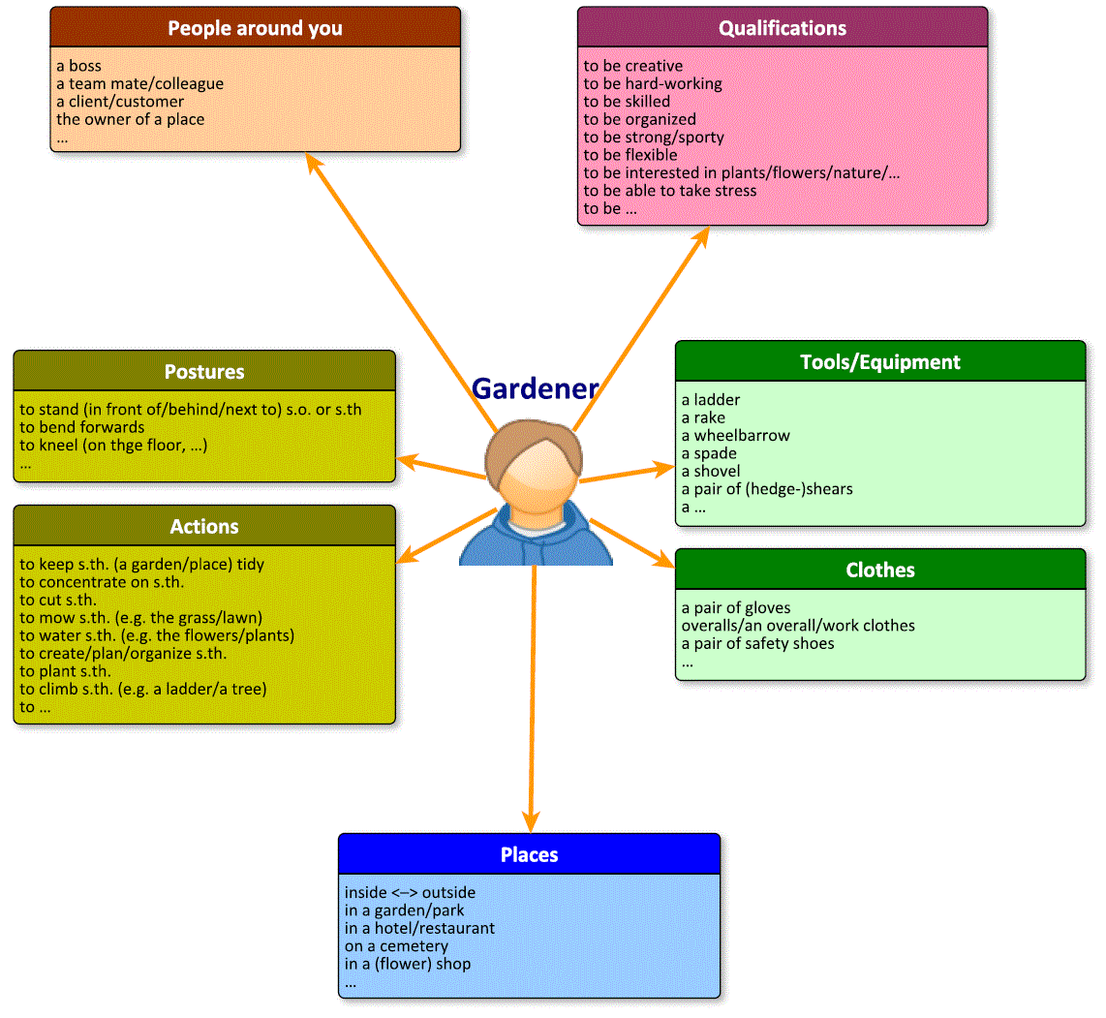

Topical language support – hairdresser

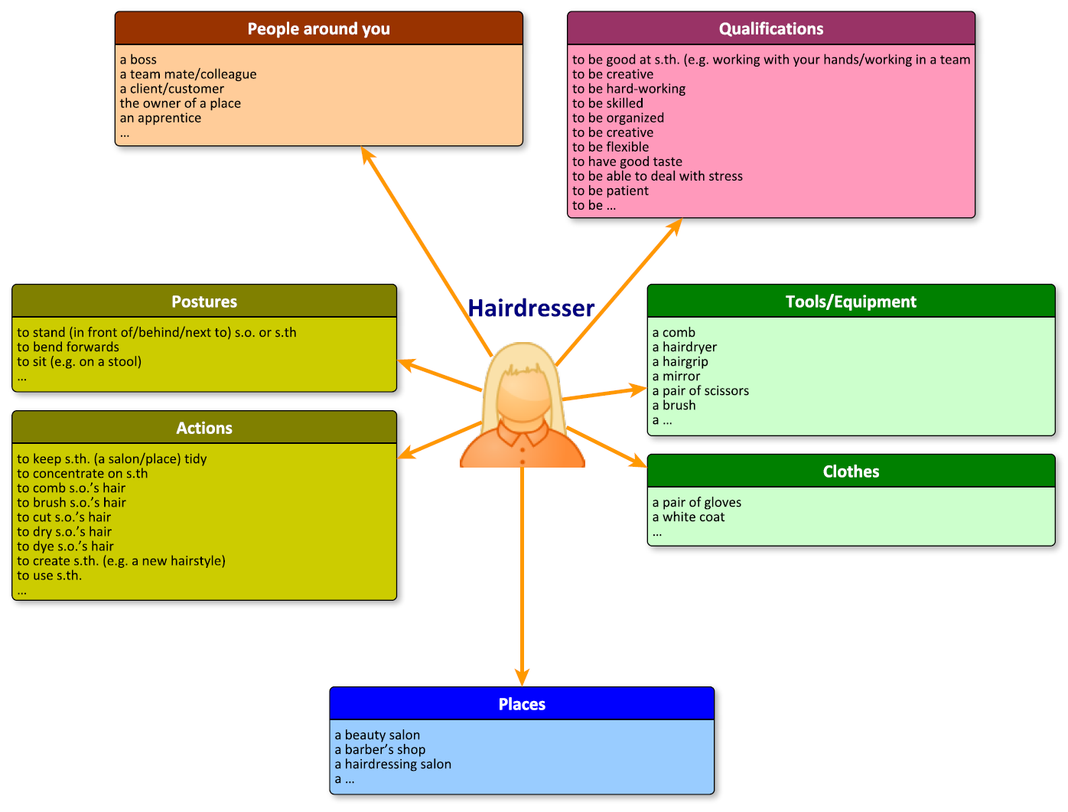
Language support: Comparing jobs – How to prepare the presentation
- Starting your presentation

- Say something general, for e.g.
- I’m going to talk about two different kinds of jobs which are shown in these two photos.
- The first photo that I’m going to describe shows …
- In the second photo …
- …

- Description of the photos

- Describe all the details in a structured way, e.g.
- In the foreground/in the background/next to/between/in the centre/...
- Refer to the time of day morning/afternoon/evening/…
- Refer to the weather it’s sunny/rainy/cloudy/pouring with rain/…
- Describe the people’s outward appearance What do they look like?(hair, face, body)/ What are they wearing?
- Describe the place where the people are Are they inside or outside?
- Describe the activities What are the people in the photo doing?
- Describe the atmosphere How do the people feel? (expression on their faces)
- …

- Use words like but, because, although ... e.g.
- She seems to like her job because she’s smiling brightly.
- …

- Use relative clauses e.g.
- The young woman/man, who …
- The room, which …
- …

- Use adjectives when you are describing people and places.
- If you don’t know a word or an expression try to explain it.

- Choosing the job you prefer

- Choose one of the jobs and say what you like about it. (Talk about everything you can think of and say more than one or two sentences.)

- Explain why you prefer the job and give reasons (more than one), if necessary.

- If you do not like any of the two jobs then be honest and say why you don’t like them. (Talk about both jobs then.)

Aufgaben – erster Prürfungsteil
Name: __________________________________________________________
Part 1 (individual task): Comparing jobs
You have 10 minutes to prepare for your presentation. Make notes only.
Picture 1

© Moodboard / 123rf
Annotations: ---

Picture 2

© Christopher Futcher / iStock

Annotations: ---

Tasks:
- Describe the two photos in detail. What kinds of jobs are presented here?
- Choose the job that you would prefer to do and explain why.

Comparing jobs: gardener – childcare assistant
Inhaltliche Leistung
Teilaufgabe | Anforderungen
 | Der Prüfling …
1 | beschreibt die Fotos im Detail und benennt die dargestellte Tätigkeit, z. B.:  - two pictures that show people doing their jobs  - …  Picture 1:  - a young man, working outside (in a garden): a gardener  - in the foreground: different kinds of flowers in a wheelbarrow  - the young man, wearing a green T-shirt and blue jeans  - in the background: flower pots, more flowers, …  - …  Picture 2:  - a young (coloured) woman, playing with children: childcare assistant  - in the foreground: four children sitting around a table, the young woman is showing them s.th. and the children are watching her  - in the background: a shelf with boxes, toys, etc. kindergarten  - …
2 | wählt eine der dargestellten Tätigkeiten als die bevorzugte und begründet, z. B.  - I (would) prefer the job of the … because I like working outside/inside.  - I like the job of the … because I`m interested in…  - I don’t like …, so I wouldn’t want to work with/ in a …  - I’m good at working …  - I like/enjoy/love working …  - I’m interested in working (with)…, so…  - I’m a very creative/social/patient/reliable/… person, so…  - The working hours are from …, so …  - For this job you need … (tools, equipment, support) and I like working with…  - When you work as a … you can help other people/arrange/organise/  repair… so…  - …

Mögliche Impulse/weiterführende Fragen:
Teilaufgabe 1:
- Where does the person work?
- What is the person wearing?
- What does the person do exactly?
- What does the person need for the job (tools, equipment …)?

Teilaufgabe 2:
- What are you good at?
- What are you interested in?
- When would you prefer to work?
- Where would you prefer to work?
- Would you like to work in a team? Say why/why not.

Name: ___________________________________________________________

Part 1 (individual task): Comparing jobs
You have 10 minutes to prepare for your presentation. Make notes only.
Picture 1

© Kzenon/Alamy

Annotations: ---

Picture 2

© Wavebreak Media Ltd / 123rf

Annotations: ---

Tasks:
- Describe the two photos in detail. What kinds of jobs are presented here?
- Choose the job that you would prefer to do and explain why.
Comparing jobs: cook – car mechanic
Inhaltliche Leistung
Teilaufgabe | Anforderungen
 | Der Prüfling …
1 | beschreibt die Fotos im Detail und benennt die dargestellte Tätigkeit, z. B.:  - two pictures that show people doing their jobs  - …  Picture 1:  - a young woman, working in a big kitchen: a (female) cook  - in the foreground: the woman is pouring oil into a pan  - she’s wearing a white coat and a red scarf  - on the left there’s a pot on the stove/cooker  - in the background: a kitchen sink, a pepper mill, more kitchen/ cooking equipment, vegetables, …  - …  Picture 2:  - a young man, bending forwards and repairing a car: car mechanic  - he’s wearing blue overalls  - in the foreground: the bonnet of a car is up so you can see the engine  - the mechanic is pointing at s.th./touching s.th. with his left hand and with his right hand he’s typing out s.th. on a laptop  - in the background: a house, probably the garage  - …
2 | wählt eine der dargestellten Tätigkeiten als die bevorzugte aus und begründet seine Wahl, z. B.:  - I (would) prefer the job of the … because I like working in a …/ inside/ outside.  - I like the job of the … because I’m interested in…  - I don’t like …, so I wouldn’t want to work with/ in a …  - I’m good at working with my hands and therefore I’d …  - I like/enjoy/love working …  - I’m interested in working (with)…, so…  - I’m a very skilled/creative/reliable/… person, so…  - The working hours are from …, so I would/wouldn’t like to …  - For this job you need … (tools, equipment, support) and I like working with…  - When you work as a … you can help other people arrange/ organise/ repair…so…  - I like working in a team, so…  - …

Mögliche Impulse/weiterführende Fragen:

Teilaufgabe 1:
- What kinds of jobs are shown?
- Where does the person work?
- What is the person wearing?
- What does the person do exactly?
- What does the person need for the job (tools, equipment …)?

Teilaufgabe 2:
- What are you good at?
- What are you interested in?
- When would you prefer to work?
- Where would you prefer to work?
- Would you like to work in a team? Say why/why not.

Name: ___________________________________________________________
Part 1 (individual task): Comparing jobs
You have 10 minutes to prepare for your presentation. Make notes only.
Picture 1

© Wavebreak Media Ltd / 123rf
Annotations: ---
Picture 2
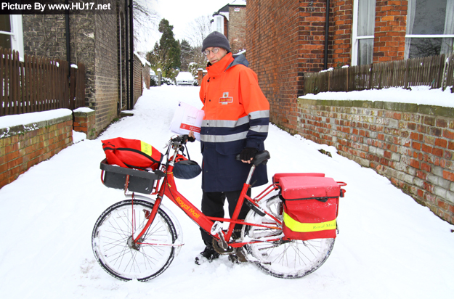

© Photo Credit – Paul Smith / www.HU17.net

Annotations: ---

Tasks:
- Describe the two photos in detail. What kinds of jobs are presented here?
- Choose the job that you would prefer to do and explain why.

Comparing jobs: baker – postman
Inhaltliche Leistung
Teilaufgabe | Anforderungen
 | Der Prüfling …
1 | beschreibt die Fotos im Detail und benennt die dargestellte Tätigkeit, z. B.:  - two pictures that show people doing their jobs  - …  Picture 1:  - a scene in a big kitchen: a baker  - a young woman is kneading/mixing dough  - she’s wearing a white coat and a cap/holding a green plastic bowl  - in the foreground: some muffins/cupcakes, eggs, lemons, a metal dish  - in the background: a big oven/microwave, a stove/cooker  - on the left: an emergency exit  - …  Picture 2:  - a man working outside in a street: a postman  - the photo was taken in winter and the man is standing behind his bike  - a snow-covered road and the postman`s bike (with ‘Royal Mail’ printed on it)  - at the front and the back of the bike there are bags for the post (letters, parcels …)  - behind the bike: the postman, wearing a blue and orange winter jacket and a woollen hat  - in the background: houses, a road, a car  - …
2 | wählt eine der dargestellten Tätigkeiten als die bevorzugte aus und begründet seine Wahl, z. B.:  - I like the job of the … because I’m interested in…  - I don’t like …, so I wouldn’t want to work with/ in a …  - I’m good at working …  - I like/enjoy/love working/making/doing ….  - I’m interested in working (with)…., so…  - I’m a very skilled/creative/reliable/organised… person, so…  - The working hours are from ……, so …  - For this job you need … (tools, equipment, support) and I like working with…  - When you work as a … you can prepare/deliver/organize… for other people  - …

Mögliche Impulse/weiterführende Fragen:

Teilaufgabe 1:
- What kinds of jobs are shown?
- Where does the person work?
- What is the person wearing?
- What does the person do exactly?
- What does the person need for the job (tools, equipment …)?

Teilaufgabe 2:
- What are you good at?
- What are you interested in?
- When would you prefer to work?
- Where would you prefer to work?
- Would you like to work in a team? Say why/why not.
Name: ___________________________________________________________
Part 1 (individual task): Comparing jobs
You have 10 minutes to prepare for your presentation. Make notes only.
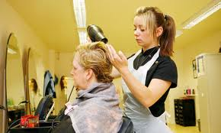Picture 1

© Guardian News & Media LTD 2011 / David Sillitoe

Picture 2

© Lisa F. Young / Alamy
Annotations: ---
Tasks:
- Describe the two pictures in detail. What kinds of jobs are presented here?
- Choose the job that you would prefer to do and explain why.
Comparing jobs: hairdresser – plumber
Inhaltliche Leistung
Teilaufgabe | Anforderungen
 | Der Prüfling …
1 | beschreibt die Fotos im Detail und benennt die dargestellte Tätigkeit, z. B.:  - two pictures that show people doing their jobs  - …  Picture 1:  - a scene in a hairdressing salon: a hairdresser  - in the foreground: the young hairdresser, is drying a woman’s hair  - she’s concentrating on her job  - the client is looking in the mirror/watching the hairdresser  - in the background: more mirrors, chairs, cupboards for the equipment and shelves with bottles  - …  Picture 2:  - a man working in a bathroom: a plumber  - in the foreground: the plumber is wearing a helmet and kneeling on the floor  - he is holding a tool (a pair of pliers) in his right hand  - on the left there’s a toilet and behind the toilet there’s a washbasin  - there’s a hole in the wall and you can see some pipes so the man is repairing s.th.  - in the background: some shelves, a shower…  - …
2 | wählt eine der dargestellten Tätigkeiten als die bevorzugte aus und begründet seine Wahl, z. B.:  - I like the job of the … because I’m interested in…  - I don’t like …, so I wouldn’t want to work with/ in a …  - I’m good at working …  - I like/enjoy/love working/repairing/doing ….  - I’m interested in working (with)…., so…  - I’m a very skilled/creative/reliable/… person, so…  - The working hours are from ……, so …  - For this job you need … (tools, equipment, support) and I like working with…  - When you work as a … you can help other people arrange/organise/  repair… so…  - …

Mögliche Impulse/weiterführende Fragen:

Teilaufgabe 1:
- What kinds of jobs are shown?
- Where does the person work?
- What is the person wearing?
- What does the person do exactly?
- What does the person need for the job (tools, equipment …)?

Teilaufgabe 2:
- What are you good at?
- What are you interested in?
- When would you prefer to work?
- Where would you prefer to work?
- Would you like to work in a team? Say why/why not.
Material für den Unterricht – zweiter Prüfungsteil
Language support – Having a conversation
FIRST clearly state your opinion on the topic.
- I think …
- In my opinion … / My opinion is …
- That’s how I see it …
- The way I see it …
- …

THEN you discuss the topic.
- What about you? / What do you think / feel about …?
- What’s your opinion on …?
- Do you agree? / Don’t you agree?
- Are you saying that …?
- If you ask me …
- Well, actually, I think …
- I’m not sure but …
- I agree (with you) …
- Well, I don’t think so. I see your point but …
- I see what you mean but …
- OK, but listen to my idea. I want to …
- Let me give you one example. / As an example … / For example …
- That’s a very good point.
- You must be kidding / joking.
- No way! I wouldn’t say that …
- and / also / …, too
- but / however / yet
- so / because of that / therefore …
- first(ly) / second(ly) / third(ly) …
- …

FINALLY say whether you agree with your friend or not and why (not).
- Finally / to sum up …
- You’re right. / That’s true. / I agree.
- Right, so we agree (on) ...
- Well, I think you’re wrong here.
- I’m sorry, but I don’t agree.
- That’s it then. / OK then.
- …
Aufgaben – zweiter Prüfungsteil
Name: _____________________________________________________________
Part 2 (Role-play) – Part-time jobs
Situation: You and your friend are having a conversation about working part-time.
Role A
You are still at school and would like to get a part-time job.
Try to convince your friend that this is a good idea.
FIRST clearly state your opinion on the topic.
THEN you may talk about …
- job experience.
- extra money.
- being independent.
Find more ideas …
FINALLY say whether you agree with your friend or not and why (not).

Name: _____________________________________________________________
Part 2 (Role-play) – Part-time Jobs
Situation: You and your friend are having a conversation about working part-time.
Role B
You think working part-time is not a good idea as long as you are still at school.
Try to convince your friend that he/she should finish school first.
FIRST clearly state your opinion on the topic.
THEN you may talk about …
- school performance.
- stress.
- friends and family.
Find more ideas …
FINALLY say whether you agree with your friend or not and why (not).
Role-play – Part-time Jobs
Inhaltliche Leistung
Anforderungen – Role A
Der Prüfling …
bringt seine Position zum Thema klar zum Ausdruck, z. B.:
- I’m looking for a part-time job. I think it’s a good way to make some extra money.
- ...
nennt Argumente, die den Gesprächspartner/die Gesprächspartnerin von seiner/ ihrer Position überzeugen sollen, z. B.:
- advantages:
- getting some job experience good for later career
- not having to ask parents for money being more independent
- doing some practical work good balance for learning at school
- …
- …
erklärt abschließend, ob er mit seinem Gesprächspartner/seiner Gesprächspart-nerin übereinstimmt oder nicht, z. B.:
- I’m sorry, but I don’t agree, for me ….
- …
Anforderungen – Role B
Der Prüfling …
bringt seine Position zum Thema klar zum Ausdruck, z. B.:
- Well, in my view that’s not a good idea. I think …
- …
reagiert auf die Äußerungen des Gesprächspartners/der Gesprächspartnerin und nennt Argumente, die die Position des/der anderen entkräften, z. B.:
- disadvantages:
- risk of getting bad marks at school
- very stressful
- no time left for your hobbies and friends
- …
- …
erklärt abschließend, ob er mit seinem Gesprächspartner/seiner Gesprächspartnerin übereinstimmt oder nicht, z. B.:
- Honestly, I think you should (not) ...
- …

Name: _____________________________________________________________
Part 2 (Role-play) – Work experience in social jobs
Situation: Your school has decided that you have to look for a job for your work experience. You have to find a place in social work.
Role A
You are enthusiastic about the idea of doing social work for some time.
Talk to your partner and try to convince him / her that this is a great idea.
FIRST clearly state your opinion on the topic.
THEN you may talk about …
- the advantages of doing social job work.
- what kinds of jobs could be interesting.
- positive effects on your personality.
Find more ideas …
FINALLY say whether you agree with your friend or not and why (not).

Name: _____________________________________________________________
Part 2 (Role-play) – Work experience in social jobs
Situation: Your school has decided that you have to look for a job for your work experience. You have to find a place in social work.
Role B
You cannot understand why your friend is so keen on doing social work.
Talk to your partner and try to convince him/her that doing social work is not as easy as he/she thinks it is.
FIRST clearly state your opinion on the topic.
THEN you may talk about …
- the difficulties in finding a suitable job.
- stressful situations in certain jobs (giving examples).
- negative effects doing social work may have on you.
Find more ideas …
FINALLY say whether you agree with your friend or not and why (not).
Role-play – Work experience in social jobs
Inhaltliche Leistung
Anforderungen – Role A
Der Prüfling …
bringt seine Position zum Thema klar zum Ausdruck, z. B.:
- I think it’s great to do social work for some time.
- ...
nennt Argumente, die den Gesprächspartner/ die Gesprächspartnerin von seiner Position überzeugen sollen, z. B.:
- advantages of doing social work:
- helping people who need you
- …
- interesting jobs: working in a hospital / in an old people’s home
- …
- feeling accepted / needed makes you happy
- …
erklärt abschließend, ob er mit seinem Gesprächspartner/ seiner Gesprächspart-nerin übereinstimmt oder nicht, z. B.:
- I’m sorry, but I don’t agree, for me ….
- …
Anforderungen – Role B
Der Prüfling …
bringt seine Position zum Thema klar zum Ausdruck, z. B.:
- Hm, well, I can’t really agree with you. I think doing social work is not easy.
- …
reagiert auf die Äußerungen des Gesprächspartners/ der Gesprächspartnerin und nennt Argumente, die die Position des anderen entkräften, z. B.:
- difficulty in finding a suitable job not qualified for many social jobs
- in hospitals: hard to work with people suffering / to face death…
- getting close to people who suffer may make you feel depressed / sad
- …
erklärt abschließend, ob er mit seinem Gesprächspartner/seiner Gesprächspartnerin übereinstimmt oder nicht, z. B.:
- I’m afraid I can’t agree with you because ...
- …

Kernlehrplan für die Hauptschule in Nordrhein-Westfalen – Englisch, hrsg. v. Ministerium für Schule und Weiterbildung des Landes Nordrhein-Westfalen, Düsseldorf, Heft 3205, 1. Auflage 2011, S. 31
Kernlehrplan für die Gesamtschule – Sekundarstufe I in Nordrhein-Westfalen – Englisch, hrsg. v. Ministerium für Schule, Jugend und Kinder des Landes Nordrhein-Westfalen, Düsseldorf, Heft 3102, Ritterbach, Frechen, 1. Auflage 2004, S. 43

