Mündliche Prüfung im letzten Jahr der Sekundarstufe I – Englisch
– Orientierung am Referenzniveau B1

Environment
Informationen zur Unterrichtsreihe
Die dargestellten Vorschläge für eine mündliche Leistungsüberprüfung als Ersatz für eine Klassenarbeit basieren auf einer Unterrichtsreihe zum Thema Environment aus dem Themenfeld Teilhabe am gesellschaftlichen Leben: … Chancen und Risiken des wissenschaftlichen Fortschritts und technologischen Wandels (Umweltfragen) des grundlegendenden Orientierungswissens. Die Erweiterung und Vertiefung des themenspezifischen Orientierungswissens erfolgt anhand ausgewählter Sachtexte (auch in Form von Statistiken) sowie in Auseinandersetzung mit themenspezifischem Bildmaterial, Cartoons und Werbeanzeigen. Dabei steht die Förderung der kommunikativen Kompetenzen Sprechen: zusammenhängendes Sprechen sowie Sprechen: an Gesprächen teilnehmen im Vordergrund.
Für die Kompetenzerweiterung im Teilkompetenzbereich Verfügbarkeit sprachlicher Mittel: Wortschatz werden gemeinsam mit den Schülerinnen und Schülern die entsprechenden Redemittel sukzessive erarbeitet und jeweils in einem language support zusammengetragen (siehe hierzu die Aufstellungen auf S. 6ff.).
Im Einzelnen ist die Unterrichtsreihe ausgerichtet auf die Kompetenzerweiterung in folgenden Kompetenzbereichen:

Kompetenzbereich: Kommunikative Kompetenzen
Sprechen: zusammenhängendes Sprechen
(s. KLP SI. Gesamtschule. Englisch. S. 40)
Die Schülerinnen und Schüler können ...
- zu Themen von gesellschaftlicher Bedeutung weitgehend zusammenhängend sprechen.
- Kurzreferate mit visueller Unterstützung präsentieren und bewerten.
- Meinungen äußern und Gefühle formulieren sowie ... Texte kommentieren.
Sprechen: an Gesprächen teilnehmen
(s. KLP SI. Gesamtschule. Englisch. S. 39)
Sie können ...
- sich in unterschiedlichen Situationen des Alltags an Gesprächen beteiligen und sich ... zu Themen von gesellschaftlicher Bedeutung äußern.

- sich nach Vorbereitung argumentierend an Gesprächen beteiligen und dabei ihre eigenen Interessen, Positionen und Gefühle einbringen.

- im Rollenspiel anwendungsorientierte Gesprächssituationen erproben.

Leseverstehen
(s. KLP SI. Gesamtschule. Englisch. S. 40)
Die Schülerinnen und Schüler können ...
- Sach- und Gebrauchstexten ... wesentliche Informationen entnehmen sowie Einzelinformationen in den Kontext der Gesamtaussage einordnen.
Kompetenzbereich: Interkulturelle Kompetenzen – Orientierungswissen
(s. KLP SI. Gesamtschule. Englisch. S. 43)
Die Schülerinnen und Schüler verfügen über ein grundlegendes Orientierungswissen zu den folgenden Themenfeldern:
Teilhabe am gesellschaftlichen Leben:
Chancen und Risiken des wissenschaftlichen Fortschritts und technologischen Wandels (Globalisierung, Umweltfragen, ...)
Kompetenzbereich: Verfügbarkeit von sprachlichen Mitteln und
sprachliche Korrektheit
(s. KLP SI. Gesamtschule. Englisch. S. 43-45)
Aussprache und Intonation
Die Schülerinnen und Schüler können Aussprache- und Intonationsmuster weitgehend korrekt verwenden ...
Sie können ...
- auch in authentischen Gesprächssituationen und einfach strukturierter freier Rede Aussprache und Intonation weitgehend angemessen realisieren.
Wortschatz
Die Schüler und Schülerinnen verfügen über einen ausreichend großen Wortschatz, um sich ... zu Themenfeldern von gesellschaftlicher Bedeutung auch differenzierter äußern zu können.
Sie können produktiv und rezeptiv einen funktionalen und thematisch erweiterten Grundwortschatz im Allgemeinen angemessen und routiniert anwenden ...
Grammatik
Die Schülerinnen und Schüler können im Allgemeinen ein gefestigtes Repertoire verwendungshäufiger Strukturen einsetzen.
Sie können ...
- Dauer, Wiederholung, Abfolge von Handlungen und Sachverhalten ausdrücken (s. KLP SI. Gesamtschule. Englisch. S. 34).

[ für die Unterrichtsreihe insbesondere die für Bildbeschreibungen wichtigen Zeiten: simple present, present progressive, present perfect]

- weitere Modalitäten ausdrücken (modals and their substitutes).

- räumliche, zeitliche und logische Bezüge innerhalb eines Satzes ausdrücken (conditional clauses).

Kompetenzbereich: Methodische Kompetenzen
(s. KLP SI. Gesamtschule. Englisch. S. 46)
Sprechen (und Schreiben)
Die Schülerinnen und Schüler können ein vielseitiges Inventar von Lern- und Arbeits-techniken in der Regel routiniert für das selbständige und kooperative Lernen nutzen.
Sie können ...
- Techniken zur Planung, Produktion und Kontrolle mündlicher ... Texte einsetzen (Stichworte, Gliederungen, Handlungsgeländer ... anfertigen).

- Texterschließungstechniken ... einsetzen (s. KLP SI. Gesamtschule. Englisch. S. 34).

[ für die Unterrichtsreihe insbesondere die Fokussierung auf typische Bild- und Layout-Elemente in Werbeanzeigen oder Broschüren)
Umgang mit Texten und Medien
(s. KLP SI. Gesamtschule. Englisch. S. 47)
Die Schülerinnen und Schüler können ...
ein grundlegendes analytisch-interpretierendes Instrumentarium einsetzen, um die Wirkung von Texten zu beschreiben.
Selbständiges und kooperatives Sprachenlernen
(s. KLP SI. Gesamtschule. Englisch. S. 48)
Die Schülerinnen und Schüler können ...
- Lern- und Arbeitsprozesse selbständig und kooperativ gestalten.

- Techniken der systematischen Wortschatzerweiterung und -sicherung anwenden.

- das Englische in kooperativen Unterrichtsphasen gezielt als Gruppenarbeitssprache einsetzen.

Wortschatz erster und zweiter Prüfungsteil
Environment – Topical language support
Environmental / Ecological Problems
Environmental pollution
to damage / to pollute the environment

Tropical rainforest
deforestation
to cut down the rainforest
to use up natural resources

Global warming
greenhouse effect
to cause global warming / the greenhouse effect
rising co² / carbon dioxide emissions
the depletion of the ozone layer
to cause droughts

The pole / polar ice-caps
to melt
rising sea levels
to flood coastal regions / islands
to endanger someone / something
endangered species
to become extinct
to be harmful to wildlife
to destroy people’s / animals’ natural habitat / to be driven out of one’s natural habitat
to live in a throw-away society
to produce rising mountains of waste / litter
waste dump
to dump waste
to dispose of (one’s waste)

Taking Action
to protect the environment
to use alternative energy
to consume / use less energy / to save energy
to cut emissions
to raise environmental awareness
to go green
to reduce pollution
to recycle / recycling
to separate waste
re-use facility
to use renewable energies
to use solar power / energy
to maintain / shift to a (more) sustainable lifestyle
to eat seasonal food

Environment: Language support – How to analyse an advertisement
STEP 1: DESCRIPTION – What is shown? | Useful phrases
Introductory sentence(s)  - Name …  - where the ad was published (if known).  - what kind of product is advertised.  - the name of the product and company (if known).  - what kind of picture it is (photo, drawing, montage, etc.).  Systematic description of the ad (e.g. from  foreground to background, from top to bottom, from left to right).  - Describe in detail …  - what / who is shown.  - Where is the ad set?  - How many people are shown?  - What is their relationship?  - What are they doing?  - Describe their appearance (age, clothes, facial expressions and body language, etc.).  - How is the product presented? (size, colour, number, etc.)  - the text used in the ad.  - What does it say?  - How is the text presented? (layout, typeface, size, colour(s), etc.) | - The ad was published on (date) in the newspaper … / on the internet.  - It is an ad for …  - The ad shows ... / is about ...  - The situation that is presented shows ...  - …  - There is ... / There are ...  - The ad is set in /at …  - In the ad one can see ...  - The ad shows a picture of ...  - The largest part of the ad shows ...  - At the top ... / At the bottom ...  - In the foreground ... / In the background ...  - In the centre ...  - On the left ... / On the right ...  - In the bottom right-hand corner ...  - In the top left-hand corner ...  - Furthermore you can see ...  - There is a pictogram / icon showing …  - Some words are printed in bold type / … italics / … capital letters / …  - Some of the text looks handwritten.  - The text refers to … / … describes … / gives information about …  - …
STEP 2: ANALYSIS – What is the effect? | Useful phrases
- Analyse the effect of the ad.  - Explain …  - how the reader’s attention is attracted / caught.  - how the product is presented – if shown.  - why the product is not shown.  - the use of images, text, captions, logos, colours, etc.  - the effect of the people’s facial expressions and body language.  - the underlying message of the ad. (What is the ad trying to say / criticise …?)  - who the ad is made for (target group: age, sex, culture, etc.). | - The ad is very eye-catching / shocking / funny /… because / through its use of ...  - The ad appeals to the reader directly by ... (-ing) …  - The layout / The use of colour supports the impression of ...  - The bold / capital letters attract the reader’s attention.  - The text underlines the quality of the  product because …  - The ad criticises / makes fun of ...  - The ad clearly shows that ...  - The ad is meant to show the reader ...  - The ad conveys the message that ...  - …
STEP 3: EVALUATION – What do YOU think? | Useful phrases
- Comment on …  - whether the ad is successful in making the reader want to buy the product?  - the effect the ad has on you. (e.g. Would you buy this product? Have you already bought this or a similar product?) | - The ad is very successful / not very successful in ...(-ing)  - The ad fails to convince ...  - The ad does not really convince me of ...  - The ad could have been more effective if it had ...  - I think/In my opinion the ad is (un)suitable / (in)appropriate / (un)believable / (in)credible …  - …
Environment: Language support – How to analyse a cartoon/picture

STEP 1: DESCRIPTION – What is shown? | Useful phrases
Introductory sentence(s)  - Name …  - where the cartoon / picture was published (if known).  Systematic description of the cartoon / picture  (e.g. from foreground to background, from top to bottom, from left to right).  - Describe in detail …  - where the cartoon / picture is set (location)  - what / who is shown …  - people / cartoon characters / animals / landscapes  - people’s / cartoon characters’  appearance (age, clothes, facial expressions, body language, etc.)  - people’s / cartoon characters’ actions / relationships  - the text used in the cartoon.  - What does it say?  - How is the text presented? (typeface, size, colour(s), in speech / thought  bubbles, etc.) | - The cartoon / picture was published on (date) in the newspaper … / on the internet.  - The cartoon / picture is about / deals with the problem of ...  - The cartoon / picture is set in / at …  - In the cartoon / picture one can see ...  - The cartoon / picture shows ...  - The largest part of the cartoon / picture is taken up by ...  - At the top ... / At the bottom ...  - In the foreground ... / In the background ...  - In the centre ...  - On the left ... / On the right ...  - In the bottom right-hand corner ...  - In the top left-hand corner ...  - Furthermore you can see ...  - In the speech / thought bubble one can read that …  - The bubble(s) refer(s) to … / describe(s) … / give(s) information about …  - Under the cartoon / picture there is a caption saying …  - Some words are printed in bold type / … italics / … capital letters / …  - …
STEP 2: ANALYSIS – What is the effect? | Useful phrases
- Analyse the effect of the cartoon / picture.  - Explain …  - how the reader’s attention is attracted / caught.  - the effect of …  - people’s / characters’ facial  expressions and body language  - people’s actions  - the objects shown in the picture.  - the underlying message of the cartoon / picture (What is the cartoonist / photographer trying to say / criticise / make fun of…?)  - who the cartoon / picture is made for (target group: age, sex, culture, etc.). | - The cartoon / picture is eye-catching / shocking / funny /… because / through its use of ...  - The cartoon / picture appeals to the reader directly by ... (-ing) …  - The use of colour(s) supports the impression of ...  - The character’s facial expressions / body language reveal(s) that …  - You see from … that …  - The cartoon / picture criticises / makes fun of ...  - The cartoon / picture is meant to criticise … / that …  - The artist / cartoonist / photographer wants to convey the message that ...  - The cartoonist’s / photographer’s / artist’s point seems to be that …  - The (funny, ironical) caption highlights the idea that …  - …
STEP 3: EVALUATION – What do YOU think? | Useful phrases
- Comment on …  - how effective the cartoon / picture is. (How does the reader react to the cartoon / picture: does it make him smile / laugh out loud /  worry about …?)  - the effect the cartoon / picture has on you. | - The cartoon / picture is effective in convincing ...  - The cartoon / picture is very successful / not very successful in ... (-ing)  - The cartoon / picture fails to convince the reader / me of ...  - The cartoon / picture could have been more effective if it had ...  - I think/In my opinion the cartoon / picture is (un)suitable / (in)appropriate / (un)believable / (in)credible …  - …

Environment: Language support – How to discuss

FIRST clearly state your opinion on the topic.
- I think …
- In my opinion … / My opinion is …
- From my point of view … / My point of view is …
- In my view … / My view is …
- I strongly believe that …
- That’s how I see it … / The way I see it, …
- …
THEN discuss the topic.
- What about you? / What do you think / feel about …?
- What’s your opinion / view on …?
- Do you agree? / Don’t you agree?
- Are you saying that …?
- Are you trying to tell me that …?
- If you ask me …
- Well, actually, I think …
- I am not sure but …
- I agree (with you) …
- I’m sorry, but I cannot agree (with you) here …
- Well, I don’t think so. I see your point but … / I see what you mean but …
- OK, but listen to my idea. I’d like to …
- Let me give you one example. / As an example … / For example …
- That’s a very good point.
- You must be kidding / joking.
- No way! I wouldn’t say that …
- and / in addition / additionally / moreover / furthermore / on top of that / also / …, too
- but / however / …, though / even though / nonetheless / nevertheless / yet …
- so / because of that / therefore / consequently / thus / hence / …
- first(ly) / second(ly) / third(ly) / …
- …
FINALLY say whether you agree with your friend or not and why (not).
- Finally / in conclusion / to sum up …
- You’re right. / That’s true. / I agree.
- Right, so we agree (on) ...
- Well, that’s agreed then, right?
- Well, I think you’re wrong here. / … that’s wrong.
- I’m sorry, but I don’t agree. / … I disagree.
- That’s it then. / OK then.
- …

Aufgaben erster und zweiter Prüfungsteil
Für den ersten Prüfungsteil Sprechen: zusammenhängendes Sprechen sind im Folgenden drei Aufgabensets und ihre zugehörigen Erwartungshorizonte mit möglichen Schülerlösungen zusammengestellt. Das Material ist für Paarprüfungen vorgesehen und kann für insgesamt 9 Paarprüfungen bzw. 18 Schülerinnen und Schüler eingesetzt werden. In den Prüfungssets werden Anzeigen, Cartoons bzw. Bilder als Sprechimpuls verwendet. Es soll hier darauf hingewiesen werden, dass die jeweiligen Textformate unterschiedliche Anforderungsgrade für die Mündliche Prüfung zulassen, je nachdem zu welchem Zeitpunkt im Schuljahr die Mündliche Prüfung durchgeführt wird. Daher wird empfohlen, sich – bezogen auf eine Lerngruppe – für ein Textformat zu entscheiden. Hier sollen allerdings unterschiedliche Möglichkeiten als Grundlage für den ersten Prüfungsteil aufgezeigt werden. Es handelt sich dabei um folgende Themen:
- Advertisements: Homeless Polar Bear – Tarzan
- Cartoons: Earth Day – Environmental Idiots
- Pictures: Beaches – Lake (Valley Jiuzhaigou, China)/River (Guandong, China)

Die Aufgabensets zu Sprechen: an Gesprächen teilnehmen sind thematisch mit dem ersten Prüfungsteil verknüpft, können jedoch beliebig mit den Aufgabenbeispielen für Sprechen: zusammenhängendes Sprechen kombiniert werden. Dabei werden Rollenkarten zu folgenden Themen eingesetzt:
- Green Club at School
- Making a difference – What About ME?
- Neighbourhood Action Group

Im Folgenden werden zunächst die Aufgaben und beispielhaften inhaltlichen Leistungen für den ersten Prüfungsteil aufgeführt. Daran schließen sich die Rollenkarten mit den jeweiligen beispielhaften inhaltlichen Leistungen an.
Pupil A – Name: _____________________________________________________

Part 1 (individual task): Environment – Homeless Polar Bear

You have 15 minutes to prepare for your individual task.

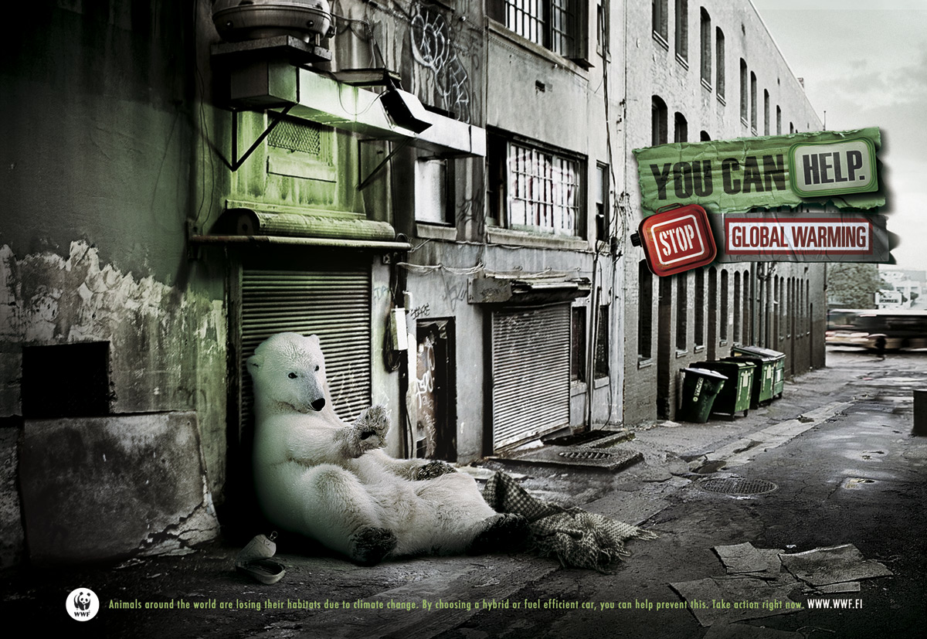

You Can Help. Stop Global Warming. Animals around the world are losing their habitats due to climate change. By recycling glass, plastic, cardboard and paper, you can help prevent this.
Source: http://adsoftheworld.com/media/print/wwf_polar_bear (02.07.2012)

Annotations: ---

Assignments:
- Describe the advertisement in detail.
- Analyse the advertisement. The following questions can help you:
  - What is the effect of the advertisement on the reader?
  - What means are used to create this effect?
  - What is the message of the advertisement?
- Comment on how effective the advertisement is.
  - Refer to the reader in general. / How might the reader react?
  - Refer to its effect on you personally.
  - Give reasons for your answers.
Pupil B – Name: _____________________________________________________

Part 1 (individual task): Environment – Tarzan

You have 15 minutes to prepare for your individual task.

15 square km of rain forest disappear every minute.
Source: http://adsoftheworld.com/media/print/wwf_tarzan (02.07.2012)

Annotations: Liane/Schlingpflanze – liana

Assignments:
- Describe the advertisement in detail.
- Analyse the advertisement. The following questions can help you:
  - What is the effect of the advertisement on the reader?
  - What means are used to create this effect?
  - What is the message of the advertisement?
- Comment on how effective the advertisement is.
  - Refer to the reader in general. / How might the reader react?
  - Refer to its effect on you personally.
  - Give reasons for your answers.
Environment – Homeless Polar Bear

Inhaltliche Leistung

Teilaufgabe | Anforderungen
 | Der Prüfling …
1 | beschreibt die Anzeige im Detail, z. B.:  - ad for WWF  - picture / drawing / photomontage:  - showing a street with run-down houses, litter on the ground  - in the centre: polar bear leaning against closed shutters  - in the background: three signs saying “YOU CAN HELP.”, “STOP”, ”GLOBAL WARMING”  - colours:  - street: different shades of grey (with a touch of green on the house behind the bear)  - bear: white  - signs: green, red and white  - text / slogan(s) / print / logo:  - providing information on the consequences of climate change and possible action  - …
2 | analysiert die Anzeige bzgl.  - der eingesetzten bildlichen / sprachlichen Mittel und ihrer Wirkung auf den Leser, z. B.:  - photomontage:  - bear: shown in an unusual environment comes as a surprise / attracts reader’s attention  - illustrating the consequences of climate change: melting of polar ice caps destruction of polar bears’ natural habitat  - bear: making a warning gesture with one of its paws urging people to stop climate change  - run-down street illustrating desperate situation of the bear  - colours:  - grey hopelessness  - red colour of red lights / stop signs warning: urgent need to stop climate change  - green hope  - text:  - intention: stirring the reader to action make him change his lifestyle  - …  - der generellen Aussage der Anzeige, z. B.:  - Urgent warning: unless people change their lifestyles, lots of species will become extinct.  - …
3 | kommentiert und bewertet die Effektivität der Anzeige bzgl.  - der Wirkung auf den Leser allgemein, z. B.:  - ad is as effective as a text makes the reader realise the need for change  - …  - der Wirkung auf sich selbst und begründet seine Meinung, z. B.:  - polar bear: cute and pitiful reminds me that everybody should do their bit to protect the environment  - …

Mögliche Impulse / weiterführende Fragen

Teilaufgabe 1
- Take a closer look at the bear that is shown ...
- What is he doing?
- Describe the location.
- Take a closer look at the text.

Teilaufgabe 2
- How is the reader’s attention attracted?
- Who is the ad aimed at?
- What is the ad trying to say?

Teilaufgabe 3
- Do you think an ad like this one will change people’s attitudes / behaviour?
Environment – Tarzan

Inhaltliche Leistung

Teilaufgabe | Anforderungen
 | Der Prüfling …
1 | beschreibt die Anzeige im Detail, z. B.:  - ad for WWF  - picture / drawing / photomontage:  - in the centre:  - man, Tarzan, wearing shorts, in mid-air  - has just let go of a liana to swing to the next tree  - no trees left will hit the ground in a few seconds  - on his left: straight line of trees, jungle  - under him: wasteland with tree stumps where jungle used to be  - …  - colours: deep jungle green / sky: black and grey / wasteland: brownish  - text / slogan(s) / print / logo: statistical information on shrinking rainforest  - …
2 | analysiert die Anzeige bzgl.  - der eingesetzten bildlichen / sprachlichen Mittel und ihrer Wirkung auf den Leser, z. B.:  - photomontage:  Tarzan hovering in mid-air  attracts the reader’s attention / makes him smile  shows Tarzan’s helplessness, the fact that he is caught unawares / unprepared  - colours:  highlight the sharp contrast between intact wilderness and wasteland destroyed by man  - text: background information stressing the extent of the damage  - …  - der generellen Aussage der Anzeige, z. B.:  - cutting down rainforest destroys man’s own habitat  warning: man is not prepared for the consequences of his disrespect for the environment  - …
3 | kommentiert und bewertet die Effektivität der Anzeige bzgl.  - der Wirkung auf den Leser allgemein, z. B.:  - makes the reader think about the problem of deforestation / its  consequences for mankind  - …  - der Wirkung auf sich selbst und begründet seine Meinung, z. B.:  - funny and interesting / treats a serious problem lightly raises  environmental awareness  - …

Mögliche Impulse / weiterführende Fragen

Teilaufgabe 1
- Take a closer look at the man that is shown ...
- Describe his appearance / his body language.
- What is he doing?
- Describe the location.
- Take a closer look at the text.

Teilaufgabe 2
- How is the reader’s attention attracted?
- Who is the ad aimed at?
- What is the ad trying to say?

Teilaufgabe 3
- Do you think an ad like this one will change people’s attitudes / behaviour?
Pupil A – Name: _____________________________________________________

Part 1 (individual task): Environment – Earth Day

You have 15 minutes to prepare for your individual task.

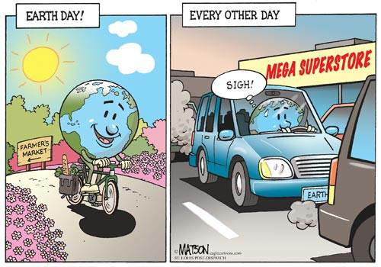
Source: http://politicalhumor.about.com/od/environment/ig/Environment-Cartoons (02.07.2012)

Annotations: ---

Assignments:
- Describe the cartoon in detail.
- Analyse the cartoon. The following questions can help you:
  - What is the effect of the cartoon on the reader?
  - What means are used to create this effect?
  - What is the message of the cartoon?
- Comment on how effective the cartoon is.
  - Refer to the reader in general. / How might the reader react?
  - Refer to its effect on you personally.
  - Give reasons for your answers.
Pupil B – Name: _____________________________________________________

Part 1 (individual task): Environment – Environmental Idiots

You have 15 minutes to prepare for your individual task.

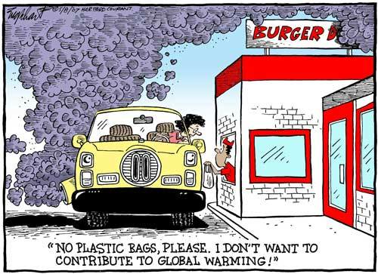
Source: http://politicalhumor.about.com/od/environment/ig/Environment-Cartoons (02.07.2012)

Annotations: ---

Assignments:
- Describe the cartoon in detail.
- Analyse the cartoon. The following questions can help you:
  - What is the effect of the cartoon on the reader?
  - What means are used to create this effect?
  - What is the message of the cartoon?
- Comment on how effective the cartoon is.
  - Refer to the reader in general. / How might the reader react?
  - Refer to its effect on you personally.
  - Give reasons for your answers.
Environment – Earth Day

Inhaltliche Leistung

Teilaufgabe | Anforderungen
 | Der Prüfling …
1 | beschreibt den Cartoon im Detail, z. B.:  - cartoon about Earth Day, consisting of two pictures  picture on the left  - showing the earth (a globe with arms and legs) riding a bike in the countryside, smiling  - in the background: road sign showing the way to a farmer’s market / pointing at the direction the earth has come from  - in a basket: groceries bought at the farmer’s market  - beautiful weather, beautiful landscape  - colours: yellow sun / blue sky / green bushes / pink flowers / earth: blue and green  picture on the right  - earth going by car to a supermarket, sandwiched between other cars  - thought bubble: earth sighing  - cars emitting fumes  - in the background: MEGA SUPERSTORE  - colours: earth: blue and green / cars, buildings, road: all grey apart from earth’s car (blue) and supermarket sign (yellow / letters printed in red)  - text / headline / caption:  picture on the left: EARTH DAY  picture on the right : EVERY OTHER DAY  - …
2 | analysiert den Cartoon bzgl.  - der eingesetzten bildlichen / sprachlichen Mittel und ihrer Wirkung auf den Leser, z. B.:  picture on the left  - smiling face of the earth, bright colours, beautiful weather and landscape  perfect day for the earth people maintaining a sustainable lifestyle  no pollution intact environment / earth  picture on the right  - worried, sad face of the earth, dull colours, exhaust fumes  everyday reality: people too lazy to go by bike / people buying  unhealthy, industrially produced food  people’s lifestyles destroying the world they live in  headlines  - highlighting the contrast between the way we act on special occasions and our everyday lifestyles  …  - der generellen Aussage der Anzeige, z. B.:  not enough to do something for the environment from time to time / need for a fundamental change in lifestyle  …
3 | kommentiert und bewertet die Effektivität der Anzeige bzgl.  - der Wirkung auf den Leser allgemein, z. B.:  It is effective because it raises environmental awareness.  …  - der Wirkung auf sich selbst und begründet seine Meinung, z. B.:  I think it is convincing, but seeing the extent of the pollution of the  environment, you sometimes feel you cannot make a difference.  …

Mögliche Impulse / weiterführende Fragen

Teilaufgabe 1
- Describe the location.
- Describe the action that is taking place in the cartoon.
- Take a closer look at the headlines.

Teilaufgabe 2
- How is the reader’s attention attracted?
- Who is the cartoon aimed at?
- What is the cartoon trying to say?

Teilaufgabe 3
- Do you think a cartoon like this one will change people’s attitudes / behaviour?
Environment – Environmental Idiots

Inhaltliche Leistung

Teilaufgabe | Anforderungen
 | Der Prüfling …
1 | beschreibt die Anzeige im Detail, z. B.:  - cartoon about so-called “environmentalists”  - location: drive-in burger restaurant  - on the left: veteran car with a woman leaning out of the window to get her meal from the waiter  - huge cloud of exhaust fumes rising from the back of the car  - on the right: drive-in burger restaurant with a waiter leaning out of the window, handing the woman a plastic bag with her meal, looking  surprised  - …  - colours  - car: pale yellow  - restaurant: white with red window / door frames, name printed in red  - waiter dressed in red  - bluish grey cloud of smoke  - caption  - woman refusing to accept a plastic bag / wants to protect the  environment  - …
2 | analysiert die Anzeige bzgl.  der eingesetzten bildlichen / sprachlichen Mittel und ihrer Wirkung auf den Leser, z. B.:  - characters’ actions  - going to a drive-in burger restaurant, driving a veteran car contributes to air pollution woman’s behaviour does not match her words  - waiter’s surprised look underlines woman’s inconsistent behaviour  - location  - drive-in burger restaurant mainly offering meat dishes / access by car not the right place for an environmentalist  - colours  - huge bluish grey cloud of exhaust fumes unrealistic highlighting the extent of the pollution  - caption  - woman’s statement stresses her stupidity makes reader smile  - …  und der generellen Aussage der Anzeige, z. B.:  - Protecting the environment means more than just using paper bags. Many people claim to protect the environment, but they just do it as long as it does not affect their personal well-being. We need to protect the environment even if it affects our personal well-being.  - …
3 | kommentiert und bewertet die Effektivität der Anzeige bzgl.  der Wirkung auf den Leser allgemein, z. B.:  - Funny, but using paper bags is a first step / helps to reduce the rising mountains of plastic waste.  - …  und der Wirkung auf sich selbst und begründet seine Meinung, z. B.:  - Convincing – makes clear that we need to do more / completely change our lifestyle.  - …

Mögliche Impulse / weiterführende Fragen

Teilaufgabe 1
- Take a closer look at the action shown in the cartoon. / What are the characters
doing?
- Describe the location.
- Take a closer look at the text / caption.

Teilaufgabe 2
- How is the reader’s attention attracted?
- Who is the cartoon aimed at?
- What is the cartoon trying to say?

Teilaufgabe 3
- Do you think a cartoon like this will change people’s attitudes / behaviour?

Pupil A – Name: ________________________________________________

Part 1 (individual task): Environment – Beaches
You have 15 minutes to prepare for your individual task.

Picture I

Source: http://www.prelovac.com/vladimir/amazing-beautiful-nature (15.10.2012)

Picture II

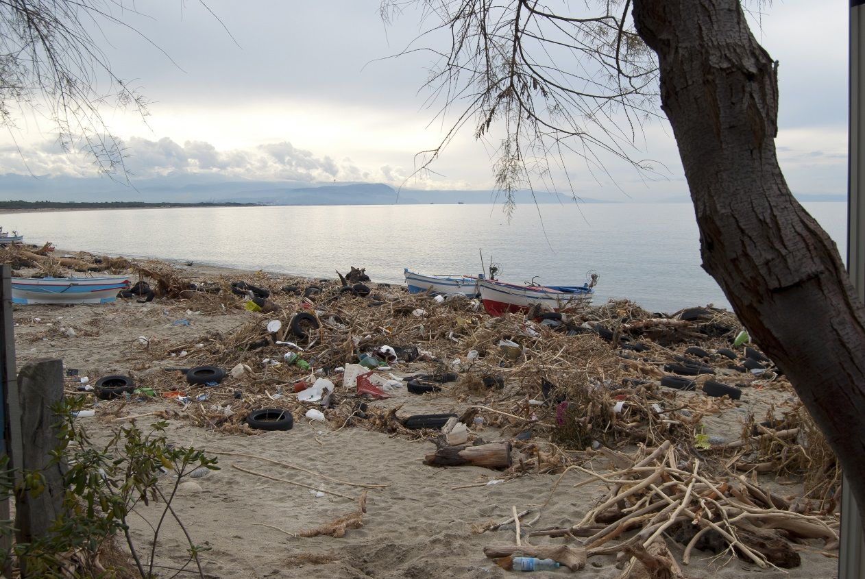

Source: © salmas/www.fotosearch.deStockFotografie

Annotations: ---
Part 1 (individual task): Environment – Beaches
Assignments:
- Describe the two pictures in detail.
- Compare the two pictures considering the state of the earth they present.
  - What are the similarities?

  - What are the differences?

  - When comparing the two pictures, what is the message for the reader’s
attitude towards the environment?
- Comment on the effect the two pictures have on you / the reader.
  - Refer to the reader in general. / How might the reader react?

  - Refer to their effect on you personally.

  - Give reasons for your answers.
Pupil B – Name: _____________________________________________

Part 1 (individual task): Environment – Lake/River
You have 15 minutes to prepare for your individual task.

Picture I: Valley Jiuzhaigou, China
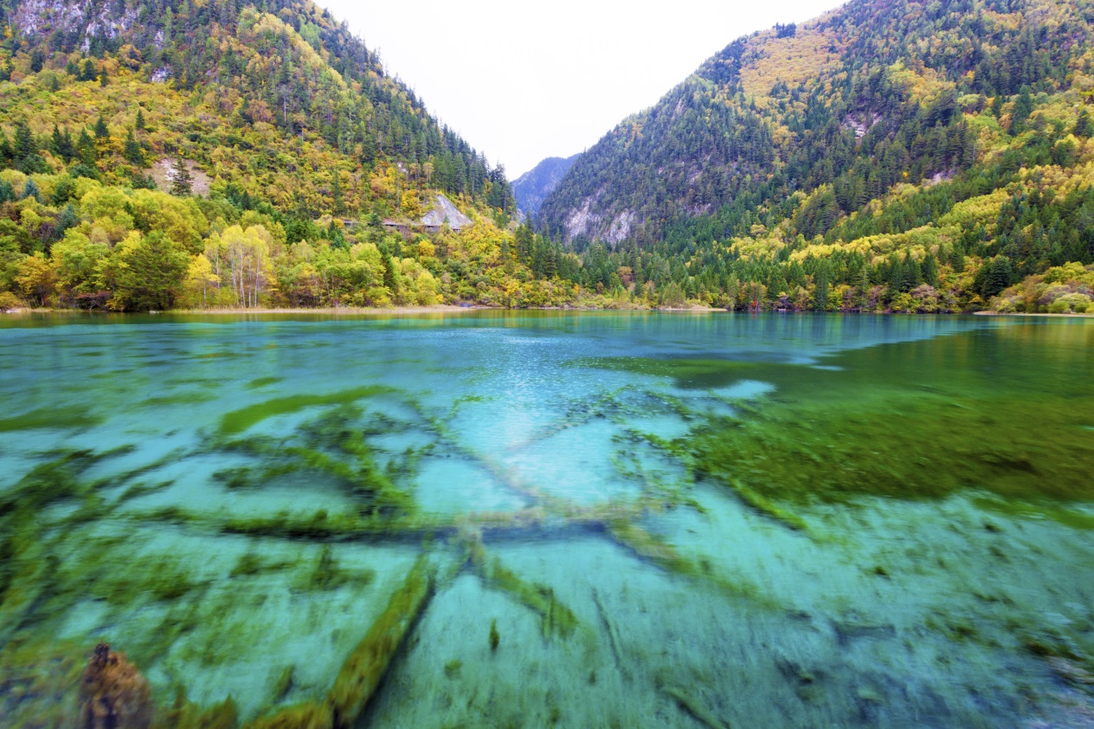

© luxizeng/iStock

Picture II: Guangdong, China
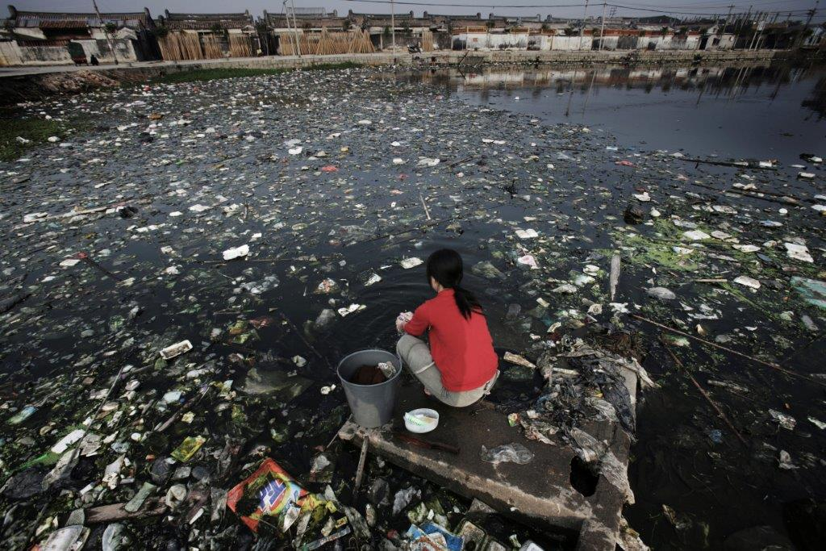

©Lu Guang/Contact Press Images/Agentur Focus

Annotations: Betonplatte – concrete slab
Part 1 (individual task): Environment – Lake/River
Assignments:
- Describe the two pictures in detail.
- Compare the two pictures considering the state of the earth they present.
  - What are the similarities?

  - What are the differences?

  - When comparing the two pictures, what is the message for the reader’s
attitude towards the environment?
- Comment on the effect the two pictures have on the reader / on you.
  - Refer to the reader in general. / How might the reader react?

  - Refer to their effect on you personally.

  - Give reasons for your answers.

Environment – Beaches

Inhaltliche Leistung

Teilaufgabe | Anforderungen
 | Der Prüfling …
1 | beschreibt die Bilder im Detail, z. B.:  - picture I  - in the centre: crystal clear sea  - in the foreground: tropical island / beautiful sandy beach with coconuts lying on the ground and palm trees on the left  - in the background: part of the shoreline with palm trees  colours  - pure white beach  - green palm trees  - light turquoise-blue sea  - blue sky with white clouds  - picture II  - main part taken up by a beach, thickly covered with litter (old tyres, plastic bottles, …)  - three boats lying on the beach  - in the foreground, on the right: part of a tree without leaves  - in the background: part of the shoreline  colours  - greyish-beige sand  - brown tree-trunk  - greyish-blue sea  - greyish-blue sky with some clouds  - …
2 | vergleicht die Bilder im Hinblick auf die jeweilige Darstellung der Natur / Umwelt, z. B.:  - similarities  - both set at the seaside, showing the ocean, beaches and trees  - differences  - picture I: intact nature, reminding the reader of Paradise  - picture II: nature used as a garbage dumping ground  - colours: picture I – bright / picture II – dull highlighting the contrast  - …  und analysiert die durch die Kontrastierung erzeugte Wirkung der Bilder auf den Leser und seine Einstellung zur Umwelt, z. B.:  - making the reader realise what man has done to nature  - showing the consequences of living in a throw-away society  - …
3 | kommentiert und bewertet die Wirkung der Bilder bzgl. der Wirkung auf den Leser allgemein, z. B.:  - Contrast is shocking, hopefully raises environmental awareness.  - …  und der Wirkung auf sich selbst und begründet seine Meinung, z. B.:  - Pictures make me realise that all of us should start reducing waste at once.  - …

Mögliche Impulse / weiterführende Fragen

Teilaufgabe 1
- Take a closer look at the two pictures that are shown ...
- Describe the locations.
- What colours are used in the pictures?

Teilaufgabe 2
- How is the reader’s attention attracted?
- What effect does picture I have on the reader? What about picture II?
- What is the reader’s reaction when looking at both pictures?

Teilaufgabe 3
- Do you think looking at these pictures will change people’s attitudes / behaviour?

Environment – River/Lake

Inhaltliche Leistung

Teilaufgabe | Anforderungen
 | Der Prüfling …
1 | beschreibt die Bilder im Detail, z. B.:  - picture I  - in the foreground: : crystal clear lake / you can even see the bottom of the lake  - in the background: mountains covered by trees  colours  - light turquoise-blue lake  - green trees  - pale blue sky  - picture II  - in the foreground: woman sitting on a concrete slab in a river, doing the laundry  - river covered with litter  - in the background: parts of a town / village stretching along the river  colours  - almost black water  - white and grey pieces of litter  - greyish-brown concrete  - brown and white houses  - grey sky  - woman’s red t-shirt  - …
2 | vergleicht die Bilder im Hinblick auf die jeweilige Darstellung der Natur / Umwelt, z. B.:  - similarities  - both set at a waterfront, showing river/lake and the surroundings in  China  - differences  - picture I: intact nature, reminding the reader of Paradise  - picture II: nature used as a garbage dumping ground contrast: woman trying to clean her clothes in a river covered with filth  - colours: picture I – bright / picture II – dull highlighting the contrast  - …  und analysiert die durch die Kontrastierung erzeugte Wirkung der Bilder auf den Leser und seine Einstellung zur Umwelt, z. B.:  - making the reader realise what man / increasing industrialisation has done to nature  - showing the consequences of living in a throw-away society for nature and humans  - …
3 | kommentiert und bewertet die Wirkung der Bilder bzgl. der Wirkung auf den Leser allgemein, z. B.:  - Contrast is shocking, hopefully raises environmental awareness.  - …  und der Wirkung auf sich selbst und begründet seine Meinung, z. B.:  - Pictures make me realise that all of us should start reducing waste at once.  - …

Mögliche Impulse / weiterführende Fragen

Teilaufgabe 1
- Take a closer look at the two pictures that are shown ...
- Describe the locations.
- What colours are used in the pictures?
Teilaufgabe 2
- How is the reader’s attention attracted?
- What effect does picture I have on the reader? What about picture II?
- What is the reader’s reaction when looking at both pictures?
Teilaufgabe 3
- Do you think looking at these pictures will change people’s attitudes / behaviour?

Name: _____________________________________________________________

Part 2 (discussion): Environment – Green Club at School

Situation: You and your friend want to do something for the environment. You think about forming a Green Club at your school.

Project: Green Club
Discuss the project with your partner.
Use the cue cards for your discussion.
Role A
Cue Cards
Introduce the project. | Talk about:  aims | Talk about:  possible activities  (2-3) | Talk about:  people / groups  involved | Come to a conclusion.

Name: _____________________________________________________________

Part 2 (discussion): Environment – Green Club at School

Situation: You and your friend want to do something for the environment. You think about forming a Green Club at your school.

Project: Green Club
Discuss the project with your partner.
Use the cue cards for your discussion.
Role B
Cue Cards
React to your partner’s idea. | Talk about:  difficulties | Talk about:  more possible activities  (2-3) | Talk about:  money | Come to a conclusion.
Discussion: Environment – Green Club at School
Inhaltliche Leistung
Anforderungen – Role A
Der Prüfling …
schlägt das Projekt Green Club vor, z. B.:
- I think we should really start doing something for the environment at our school. Why not form a Green Club, what do think?
- …
geht auf die durch die cue cards vorgegebenen Aspekte ein und reagiert auf die Äußerungen des Gesprächspartners / der Gesprächspartnerin, z. B.:
- aims
    - raise environmental awareness
    - reduce the amount of litter produced at our school by …
    - …
- possible activities
    - make posters for every classroom giving advice on how to reduce litter
use lunch boxes instead of paper / plastic bags
    - collect waste in different bins
    - …
- persons / groups involved
    - interested pupils from grades 9-10
    - biology teacher
    - …
gibt eine abschließende Stellungnahme, z. B.:
- I think doing something practical is better than just discussing the problems all the time.
- ...
Anforderungen – Role B
Der Prüfling …
bringt seine Position zum Vorschlag des Gesprächspartners / der Gesprächspartnerin zum Ausdruck, z. B.:
- Well, yes, I must say that I think it’s a good idea, (but) …
- …
reagiert auf die Äußerungen des Gesprächspartners / der Gesprächspartnerin und geht auf die durch die cue cards vorgegebenen Aspekte ein, z. B.:
- difficulties
    - pupils already have a long school day no time members will be hard to find
    - no place where the club members can meet
    - …
- more possible activities
    - clean up the school ground arrange weekly sessions of picking up litter with different classes
    - reduce energy consumption turn off the lights / electrical equipment
    - …
- money
    - organise a sponsored run to make some money
    - ask teachers, the “Förderverein” (friends’ association) for financial support
    - …
gibt eine abschließende Stellungnahme, z. B.:
- Well, perhaps you’re right, we should at least try to …
- …
Name: _____________________________________________________________

Part 2 (discussion): Environment – Making a Difference – What About ME?

Situation: You and your friend are worried about the environment and talk about making a difference.

Making a Difference – What About ME?
Discuss with your partner what you do / could do to protect the environment.
Use the cue cards for your discussion.
Role A
Cue Cards
Give your opinion on the topic. | Talk about:  energy | Talk about:  eating habits | Talk about:  difficulties | Come to a conclusion.

Name: _____________________________________________________________

Part 2 (discussion): Environment – Making a Difference – What About ME?

Situation: You and your friend are worried about the environment and talk about making a difference.

Making a Difference – What About ME?
Discuss with your partner what you do / could do to protect the environment.
Use the cue cards for your discussion.
Role B
Cue Cards
Give your opinion on the topic. | Talk about:  transport | Talk about:  your personal lifestyle | Talk about:  waste | Come to a conclusion.

Discussion: Environment – Making a Difference – What About ME?
Inhaltliche Leistung
Anforderungen – Role A
Der Prüfling …
äußert sich zu seinem persönlichen Engagement für die Umwelt, z. B.:
- You know, I sometimes feel I’m not doing enough to protect the environment, what about you?
- …
geht auf die durch die cue cards vorgegebenen Aspekte ein und reagiert auf die Äußerungen des Gesprächspartners / der Gesdprächspartnerin, z. B.:
- energy
    - switching off lights / turning off electrical equipment reducing energy
consumption
    - …
- eating habits
    - eating meat contributing to global warming
    - love for fast food rising mountains of waste
    - …
- difficulties
    - laziness
    - easy to fall into old habits
    - …
gibt eine abschließende Stellungnahme, z.B.:
- In my opinion nothing will change if people are not willing to make a difference themselves.
- ...
Anforderungen – Role B
Der Prüfling …
äußert sich zu seinem persönlichen Engagement für die Umwelt, z. B.:
- Well, it depends, sometimes I …, (but) …
- …
reagiert auf die Äußerungen des Gesprächspartners / der Gesprächspartnerin und geht auf die durch die cue cards vorgegebenen Aspekte ein, z. B.:
- transport
    - going by bike / public transport
    - sharing cars
    - …
- personal lifestyle
    - stop buying unnecessary stuff / latest gadgets
    - eating seasonal food
    - …
- waste
    - separating waste
    - refusing plastic bags
    - …
gibt eine abschließende Stellungnahme, z. B.:
- Well, you’re right, we can’t do anything about the big problems, but …
- …

Name: _____________________________________________________________

Part 2 (discussion) – Neighbourhood Action Group

Situation: You and your neighbour want to make a difference in your neighbourhood and do something for the environment. You think about forming a Neighbourhood Action Group.

Project: Neighbourhood Action Group
Discuss the project with your partner.
Use the cue cards for your discussion.
Role A
Cue Cards
Introduce the project. | Talk about:  aims | Talk about:  possible activities  (2-3) | Talk about:  persons / groups  involved | Come to a conclusion.

Name: _____________________________________________________________

Part 2 (discussion) – Neighbourhood Action Group

Situation: You and your neighbour want to make a difference in your neighbourhood and do something for the environment. You think about forming a Neighbourhood Action Group.

Project: Neighbourhood Action Group
Discuss the project with your partner.
Use the cue cards for your discussion.
Role B
Cue Cards
React to your partner’s idea. | Talk about:  difficulties | Talk about:  more possible activities  (2-3) | Talk about:  money | Come to a conclusion.
Discussion: Environment – Neighbourhood Action Group
Inhaltliche Leistung
Anforderungen – Role A
Der Prüfling …
schlägt das Projekt Neighbourhood Action Group vor, z. B.:
- I think we should really start doing something for the environment in our neighbourhood. Why not form a Neighbourhood Action Group, what do think?
- …
geht auf die durch die cue cards vorgegebenen Aspekte ein und reagiert auf die Äußerungen des Gesprächspartners / der Gesprächspartnerin, z. B.:
- aims
    - making the neighbourhood a greener / cleaner / more attractive environment
    - reduce the amount of litter polluting the neighbourhood
    - …
- possible activities
    - set up more litter bins
    - plant trees that benefit wildlife
    - …
- persons / groups involved
    - interested neighbours / volunteers
    - city council
    - …
gibt eine abschließende Stellungnahme, z. B.:
- I think starting in your neighbourhood is great because you can see the change
immediately.
- ...
Anforderungen – Role B
Der Prüfling …
bringt seine Position zum Vorschlag des Gesprächspartners / der Gesprächspartnerin zum Ausdruck, z. B.:
- Well, yes, I must say that it’s a good idea, (but) …
- …
reagiert auf die Äußerungen des Gesprächspartners / der Gesprächspartnerin und geht auf die durch die cue cards vorgegebenen Aspekte ein, z. B.:
- difficulties
    - people are stressed all the time members will be hard to find
    - spreading information on the project
    - …
- more possible activities
    - conduct a “household waste collection day” for paints, batteries, aerosol cans
recycle waste to a re-use facility
    - organise (monthly) clean-ups with volunteers
    - …
- money
    - organise a sponsored run to make some money
    - ask local businessmen for support (equipment, plants)
    - …
gibt eine abschließende Stellungnahme, z. B.:
- Well, you’re right, we can’t do anything about the big problems, but …
- …

Kernlehrplan für die Gesamtschule – Sekundarstufe I in Nordrhein-Westfalen, Englisch, S. 42f.

