Gurinder Chadha, Bend It Like Beckham
Informationen zur Unterrichtsreihe
Vorbereitung der mündlichen Prüfung im unterrichtlichen Kontext – Curriculare Bezüge
Die dargestellten Vorschläge für eine mündliche Prüfung zum Film Bend It Like Beckham finden ihre thematische Anknüpfung an die Kernlehrpläne Englisch in dem Themenfeld persönliche Lebensgestaltung (Beziehung zwischen den Geschlechtern, Jugendkulturen). In der vorbereitenden Unterrichtsreihe erweitern und festigen die Schülerinnen und Schüler ihre interkulturellen Kompetenzen insbesondere im Hinblick auf das Vergleichen von Lebensbedingungen und Lebensweisen von Menschen anderer Kulturen. Sie erläutern kulturbedingte Unterschiede und Gemeinsamkeiten und erwerben diesbezüglich ein vertieftes Verständnis.

Ein weiterer Schwerpunkt ist die Kompetenzerweiterung bezogen auf den Teilkompetenzbereich Verfügbarkeit von sprachlichen Mitteln – Wortschatz. Die Schülerinnen und Schüler erwerben hierzu ein Repertoire zur vertieften inhaltlichen Auseinandersetzung mit den unterschiedlichen Themen des Films Bend It Like Beckham wie z. B. stereotypes (role of women), women’s football, multicultural Britain (Indians, sikhism), cultural values/traditions, racism, generational problems, homosexuality. Im vorbereitenden Unterricht werden diese Themen inhaltlich aufbereitet, der entsprechende thematische Wortschatz wird mit den Schülerinnen und Schülern zusammengestellt und in verschiedensten Situationen angewendet.

Um methodisch auf die Prüfung vorzubereiten, werden die Darstellung und Beziehung von Figuren sowie setting und Handlung des Films erarbeitet. Darüber hinaus werden die Schülerinnen und Schüler in verschiedene filmtechnische Mittel sowie die Analyse ihrer Wirkung anhand von stills im Sinne der methodischen Kompetenzen eingeführt. Auch hier wird der Teilkompetenzbereich Verfügbarkeit von sprachlichen Mitteln – Wortschatz vertieft, indem der entsprechende language support wie z. B. „Vocabulary for analysis – How to analyse a still“ (s. S. 88f.) oder „Vocabulary for communication – How to discuss“ erarbeitet und in verschiedensten Situationen angewendet wird (s. S. 89).

Im folgenden Prüfungsbeispiel zum Film Bend it like Beckham sind die beiden Aufgabenteile für jede Prüfung jeweils durch eine thematische Klammer verbunden, d.h. der zweite Aufgabenteil (an Gesprächen teilnehmen) bezieht sich inhaltlich auf den ersten Aufgabenteil (zusammenhängendes Sprechen).
Materialien
Bend It Like Beckham – Topical language support
Stereotypes (role of women)
to expect somebody to be like / to do sth
football can have an integrating effect
stereotypes can be harmful
stereotypes about lifestyles / cultural and ethnic backgrounds / beliefs / race
to have mutual respect for each other
to be a victim of stereotyping
women are expected to be … / to do …
to not take somebody seriously
to make jokes about / to ridicule / to make fun of sb
to make sb act in a more … way
to want sb to do sth
to be prejudiced
to appreciate individual differences
to eliminate stereotypes
prejudiced behaviour
to be willing to understand sb
to show respect for each other’s background

(Women’s) football
to play football for a women’s team
people on the field
- captain
- a referee
- a goalkeeper
- a defender
- a midfielder
- an attacker
- a skipper
- a substitute
basic vocabulary
- match
- pitch
- foul
- offside
- the score
- to score a goal
- to equalise
- a penalty shot
- to win / to be defeated / to defeat

Generational problems (parents and children)
to be strict
to set no limits
to encourage
to give support
to support your children’s wishes
to be driven by ambition
to be proud of
to be ambitious
to be patient
to be understanding
afraid of losing his / her daughter to …
to have different opinions / views on
to be influenced by
to have faith in your children
to listen to your parents
to argue / fight
Mrs Bhamra wants Jess to cook Punjabi style
to understand your daughter’s / son’s hopes
to overcome worries

Multicultural Britain, cultural values/traditions
multicultural
multi-ethnic community
religious diversity
to belong to an ethnic minority
Indian / British culture
immigration
migrant
Asian
to be a Sikh / to belong to the Sikh community
a picture of Guru Nanak
Guru Nanak is the founder of the Sikh religion
value
to practise one’s religion
western / eastern / Asian traditions
to wear traditional / Asian / western-style clothes
a mixture of traditions
to appreciate / respect sb
traditional Indian lifestyle
to be traditional / modern
to come from different ethnic / cultural backgrounds
Bend It Like Beckham: Language support – Working with stills

STEP 1: DESCRIPTION – What is shown? | Useful phrases
Introductory sentence(s)  - Name …  - the name of the film and what is shown.  Systematic description of the still  (e.g. from foreground to background, from top to bottom, from left to right)  - Describe in detail …  - where the situation in the still is set.  - what / who is shown …  - people / characters / animals / landscapes  - people’s / characters’ appearance  (age, clothes, facial expressions, body language, etc.)  - people’s / characters’ actions / relationships  - the camera operations used in the still.  - What type of camera shot is used? (long shot, establishing shot, medium shot, close-up, etc.)  - What kind of camera angle is used? (high-angle, eye-level, low-angle?)  - Is the still shot from a character’s point of view? | - The still is from the film...  - The situation that is presented shows...  - The close-up / establishing shot / medium shot / ... shows ...  - The viewer sees ... in a close-up / establishing shot / ...  - …  - The place of action is ...  - The still conveys the setting of ...  - The situation shown in the still is set at ...  - At the top... / At the bottom...  - In the foreground / background / centre ...  - On the left / right ...  - In the bottom right-hand corner...  - In the top left-hand corner...  - Furthermore you can see...  - ... is / are presented in the still.  - In this still the viewer gets to know that ...  - …  - The director uses a long shot / close-up / ... so the viewer can see ...  - The director uses a high-angle / eye-level shot / ...  - The camera is at a great distance from ...  - The camera is very close to ...  - The camera zooms in on ...  - The still is shot from ...’s point of view / perspective ...  - ...
STEP 2: ANALYSIS – What is the effect? | Useful phrases
- Analyse the effect of the still.  - Explain …  - how the viewer’s attention is attracted / caught.  - the effect of …  - the characters’ facial expressions and body language  - characters’ appearance and actions  - the effect of the camera operations used by the director.  (What is the director trying to say /  criticise / make fun of / …?) | - The situation presented in the still is eye-catching / shocking / funny /… because / through its use of ...  - The director draws the viewer’s attention to ... by ...(-ing)  - The director achieves this effect by ...(-ing) ...  - ...  - The character’s facial expressions / body language reveal(s) that …  - The body language expresses the character’s attitude towards...  - The body language reflects ... ‘s emotions / feelings about ...  - ...’s facial expression shows how frightened / happy / uninterested / disappointed / ... the character is.  - ...  - The director uses a ... shot so the viewer can see / in order to show ...  - The ... shot / the ... angle is used to focus the viewer’s attention on ...  - The ... shot makes him / her appear ...  - The shot is taken from a high / low angle to show / emphasise / underline / ...  - The scene is shot from ...’s point of view.  - ...

STEP 3: EVALUATION / COMMENT
- Find a caption for the still that refers to the main topics of the film.  - Give reasons how the still refers to the main topics of the film (football, Indian culture, culture clash, role of women, generation conflict, racism, etc.). | - A possible caption for this still might be ...  - I have chosen this caption because ...  - The situation presented in the still refers to ...  - In this scene the viewer gets to know that ...  - The situation represents ...  - …

Bend It Like Beckham: Language support – How to discuss

Stating your opinion on the topic
- I think…
- In my opinion … / My opinion is …
- From my point of view …/ My point of view is …
- In my view …/ My view …
- I strongly believe that …
- That’s how I see it …
- The way I see it, …
- …

Discussing the topic
- What about you? / What do you think/feel about …?
- What’s your opinion/view on …?
- Do you agree? / Don’t you agree?
- Are you saying that …?
- Are you trying to tell me that …?
- If you ask me …
- Well, actually, I think …
- I am not sure but …
- I agree (with you) …
- I’m sorry but I cannot agree (with you) here …
- Well, I don’t think so. I see your point, but …
- I see what you mean but …
- OK, but listen to my idea. I want to …
- Let me give you one example. / As an example … /For example
- That’s a very good point.
- You must be kidding.
- No way! I wouldn’t say that …
- and/ in addition/ additionally/ moreover/ furthermore/ on top of that/ also/ …, too
- but/ however/ …, though/ even though/ nonetheless/ nevertheless/ yet …
- so/ because of that/ therefore/ consequently/ thus/ hence/ ...
- first(ly)/ second(ly)/ third(ly)/ …
- ….

Coming to a conclusion
- finally/ in conclusion/ to sum up …
- You’re right. / That’s true. / I agree.
- Right, so we agree (on) ...
- Well, that’s agreed then, right?
- Well, I think you’re wrong here. / … that’s wrong.
- I’m sorry but I don’t agree. / … I disagree.
- That’s it then. / OK then.
- …

Aufgaben
Das Prüfungsbeispiel Bend It Like Beckham enthält drei Aufgabenbeispiele für insgesamt 18 Prüflinge (= 9 Paarprüfungen); 6 Prüflinge (= 3 Paarprüfungen) können mit jeweils einem Prüfungsthema geprüft werden. Der erste Prüfungsteil Sprechen: zusammenhängendes Sprechen und der zweite Prüfungsteil Sprechen: an Gesprächen teilnehmen sind durch eine thematische Klammer miteinander verknüpft. Die Diskussion im zweiten Teil ergibt sich thematisch aus der Analyse der stills im ersten Prüfungsteil.

Die Aufgabenstellung für den ersten Prüfungsteil ist für alle Prüfungen gleich und findet sich mit den Themen in der folgenden Tabelle. Die stills sowie die Aufgabenstellung für den jeweiligen 2. Prüfungsteil sind im Anschluss an die Tabelle zusammengestellt. Die Erwartungshorizonte mit möglichen Schülerlösungen folgen im Anschluss an das jeweilige Prüfungsbeispiel.

Bend it like Beckham
- Move on up
- Proper woman
- What’s best for you?
Assignments:
- Describe the still in detail.
- Examine the still. The following questions can help you:

  - What is the effect the still has on the viewer?
  - What means are used to create this effect? Refer to:
    - the action(s) shown in the still
    - body language, appearance
    - shot sizes, camera angles, perspective
- Explain how the still refers to the main themes of the film.

  - Find a caption for the still that also refers to one or more of the film’s main theme(s).
  - Give reasons for your choice by referring to one or more of the film’s main theme(s).

Pupil A

Name: __________________________________________________________

Part 1 (individual task): Bend it like Beckham – Move on up
You have 15 minutes to prepare for your individual task.
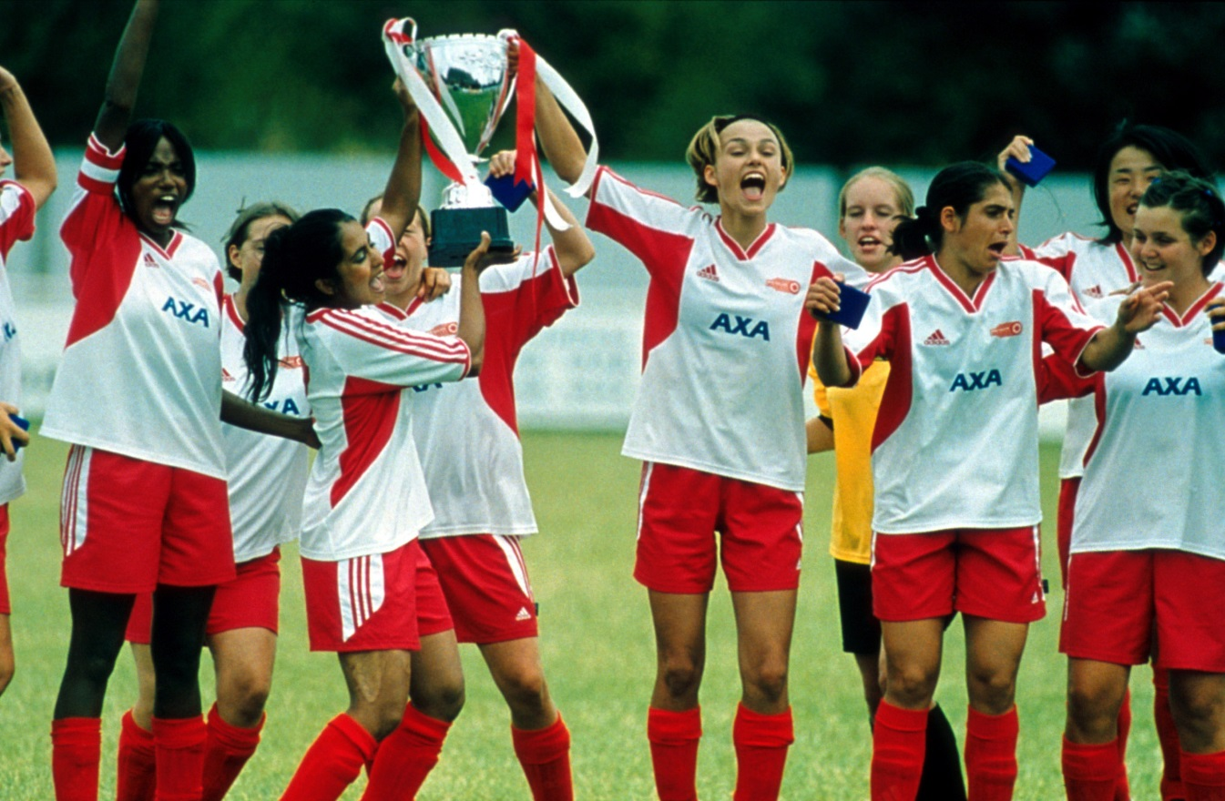

© Photos 12 / Alamy

Annotations:

---
Pupil B

Name: _________________________________________________________

Part 1 (individual task): Bend it like Beckham – Move on up
You have 15 minutes to prepare for your individual task.

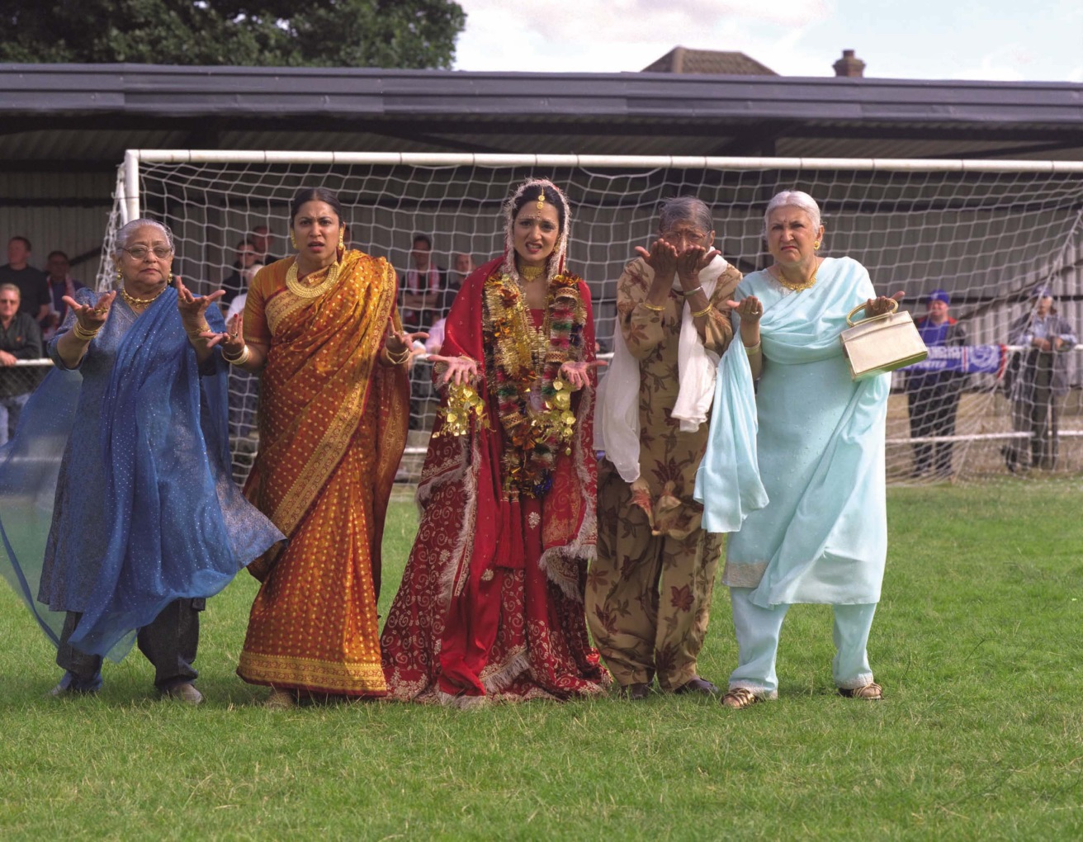

© Moviestore collection Ltd/Alamy

Annotations:

---

Part 2 (discussion) – Bend it like Beckham

You have two minutes to prepare for this task.

Move on up

There is one scene in which Jess is sneaking off to matches and training while her family thinks she is at work. The soundtrack to this scene is the song Move on up by Curtis Mayfield. One line of the lyrics says:

“… Take nothing less, not even second best
And do not obey, you must have your say …”

Tasks

FIRST explain the meaning of the line in the context of the film.
THEN discuss …
- the pros and cons of Jess’ behaviour.
- whether you think Jess is right to disobey her parents.

Give reasons and comment on your partner’s answers.
FINALLY make suggestions how Jess and her family could meet each other halfway and discuss your ideas with your partner.

Bend it like Beckham: Still ‘Move on up’ – Pupil A

Inhaltliche Anforderungen
Der Prüfling …
beschreibt das Standbild im Detail, z. B.:
- still from the film Bend it like Beckham
- Jess and Jules are celebrating their win with their team-mates
- setting:
- football field
- what / who is shown:
- centre: Jess and Jules holding the cup, jumping up and down; next to them: their team-mates also jumping up and down
- appearance Jess and Jules and their team-mates: about 18 years old: athletic and slim; wearing football jerseys; all of them are shouting and laughing
- camera operations:
- full shot; eye-level shot
- …
untersucht den Effekt, den das Standbild auf den Zuschauer bzgl. der eingesetzten bildlichen Mittel und ihrer Wirkung auf den Seher hat, z. B.:
- characters: appearance, body language, facial expression; actions
appearance / body language / facial expression
- all of them are wearing the same football jersey they belong to one team
- Jess is wearing the football jersey, too Jess belongs to the football team
- all of them are laughing and shouting they are happy/enjoying themselves
actions
- Jess, Jules and their team-mates are jumping up and down, Jess and Jules are holding a cup the team has won a championship, they are happy and celebrating
- camera operations:
- full shot showing Jess, Jules and the other girls from their team gives a good view of the scene and shows the constellation of the characters
- …
entwickelt eine Bildunterschrift, die sich inhaltlich mindestens auf ein Leitthema des Films bezieht, z. B.:
- Victory
- …
erklärt seine Bildunterschrift und somit die generelle Aussage des Standbildes im Kontext der Leitthemen des Film, z. B.:
- Jess and Jules are good friends and training partners (theme: e.g. relationships).
- Jess is heading for a new stage in her life in which sports/football and her new friends play a major role (themes: e.g. women’s football; growing up; generational conflicts).
- Jess is successful in what she does/overcomes her conflict (themes: e.g. tradition vs. modernism)…

Mögliche Impulse / weiterführende Fragen:

Teilaufgabe 1
- Take a closer look at the clothes of the characters.
- Describe the constellation of the characters.
- What are the characters doing?
- Name the camera operations.

Teilaufgabe 2
- How is the viewer’s attention attracted?

Teilaufgabe 3
- What are the main themes of the film?
- How does the still refer to any of the main themes?

Bend it like Beckham: Still ‘Move on up’ – Pupil B

Inhaltliche Anforderungen
Der Prüfling …
beschreibt das Standbild im Detail, z. B.:
- still from the film Bend it like Beckham
- full shot showing women from Jess’ family in front of a goal
- setting:
- foreground: women; background: goal
- what / who is shown:
- foreground: women of Jess’ family standing in front of a goal
- appearance: the women wearing Indian dresses; they are dressed for a wedding celebration; Pinky is wearing her wedding dress, Jess’ mother and the other
women are dressed for the wedding, too
- all of them are gesticulating wildly
- the setting is the football field in front of the goal
- camera operations:
- full shot; eye-level shot/Jess’ point of view
- …
Untersucht den Effekt, den das Standbild auf den Zuschauer bzgl. der eingesetzten bildlichen Mittel und ihrer Wirkung auf den Seher hat, z. B.:
- characters: appearance, body language, facial expression; actions
appearance / body language / facial expression
- the women are all facing a person outside the picture, they talk to this person and are gesticulating wildly they seem angry and agitated as can happen in a football match
- all of them are wearing Indian clothes for a wedding celebration respecting their Indian culture; dresses are inappropriate for a football field; the dresses are a symbol of Jess’ conflict (she wants to be a football player but also respects her
Indian roots)
actions
- women form a defensive wall Jess has to overcome her conflict and has to bend the ball to pass the women
- setting:
- football field contrast of football field and the women wearing Indian dresses symbolic of the two worlds Jess lives in
- camera operations
- full shot showing the women on the football field gives a good full body shot and shows the constellation of the characters
- eye-level shot from Jess’ perspective viewer has Jess’ perspective and gets the impression of being with her in the field
- …
entwickelt eine Bildunterschrift, die sich inhaltlich mindestens auf ein Leitthema des Films bezieht, z. B.:
- Defensive wall
- …
erklärt seine Bildunterschrift und erklärt so die generelle Aussage des Standbildes im Kontext der Leitthemen des Film, z. B.:
- The still shows the conflict Jess is in. She wants to play football but also wants to
celebrate her sister’s wedding which takes place at the same time (themes: e.g.
generational conflicts, relationships).
- On the one hand Jess respects her culture and traditions and is a good daughter who attends her sister’s wedding (themes: e.g. multicultural Britain; cultural
traditions/values); on the other hand she tries to bend the ball like Beckham (themes: women’s football; tradition vs. modernism).
- The women appear like a defensive wall and represent Jess’ conflict about living in two worlds and find her own way (themes: generational conflicts, growing up,
traditional values).
- …

Mögliche Impulse / weiterführende Fragen:

Teilaufgabe 1
- Take a closer look at the clothes of the characters.
- What are the characters doing?
- Describe the setting.
- Name the camera operations.

Teilaufgabe 2
- How is the viewer’s attention attracted?

Teilaufgabe 3
- What are the main themes of the film?
- How does the still refer to any of the main themes?

Bend It Like Beckham: Discussion – Move on up

Inhaltliche Leistung

Inhaltliche Anforderungen
Der Prüfling …

erklärt die Bedeutung der Liedzeile und ordnet sie begründet in den Kontext des Films ein, z. B.:
- one of the topics of the film is growing up and in this context finding one’s own way and making decisions
- the line refers to the fact that it is sometimes difficult to find one’s own way and that you might have to face opposition and resistance from your parents
- it also refers to the fact that you have to fight for your rights and that you have to make your point when faced with opposition
- in the context of the film this means that Jess’ parents do not want Jess to play football, they want her to be successful at school and to study medicine; they want her to follow Indian traditions and values; they find it difficult to accept that their
daughter wants to play football and is good at it
- Jess on the other hand wants to play football; she does not want to disappoint her parents but on the other hand she wants both: being successful at school, going to university and playing football
- …
bringt seine Position klar zum Ausdruck, begründet seine Aussagen durch Bezüge zur Handlung des Films und nimmt begründet Stellung zu den Aussagen seines Gesprächspartners, z. B.:
- reasons supporting her behavior:
- it is her life and she should make her own decisions
- playing football does not mean she does not respect her parents and traditions
- her parents have a very traditional image of her and do not respect her wishes
- reasons against her behaviour:
- she should respect her parents and her cultural background
- her parents are right that she should concentrate on her studies and her career
- In my opinion Jess is (not) right to disobey her parents because...
- (I can’t) agree with you because ...
- ...
macht Vorschläge wie Jess und ihre Familie einen Kompromiss finden könnten und diskutiert diese mit seinem Gesprächspartner, z. B.:
- I would suggest that Jess can play football if she agrees to ...
- Maybe her family could go and watch her play once.
- I’m sorry but I can’t agree with you on this point because ...
- …

Pupil A

Name: __________________________________________________________

Part 1 (individual task): Bend it like Beckham – Proper woman
You have 15 minutes to prepare for your individual task.

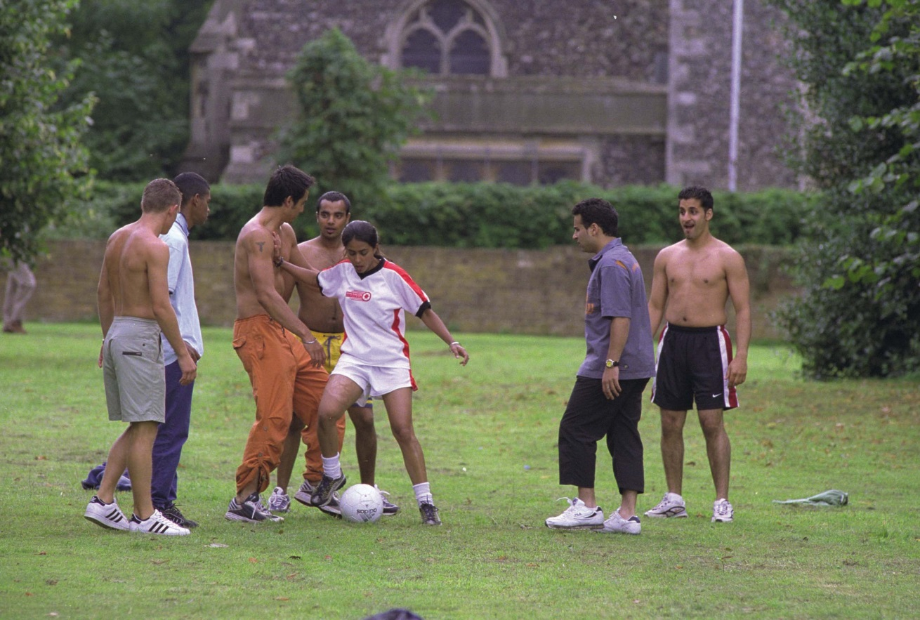

© Moviestore Collection, Ltd / Alamy

Annotations:

---
Pupil B

Name: __________________________________________________________

Part 1 (individual task): Bend it like Beckham – Proper woman
You have 15 minutes to prepare for your individual task.

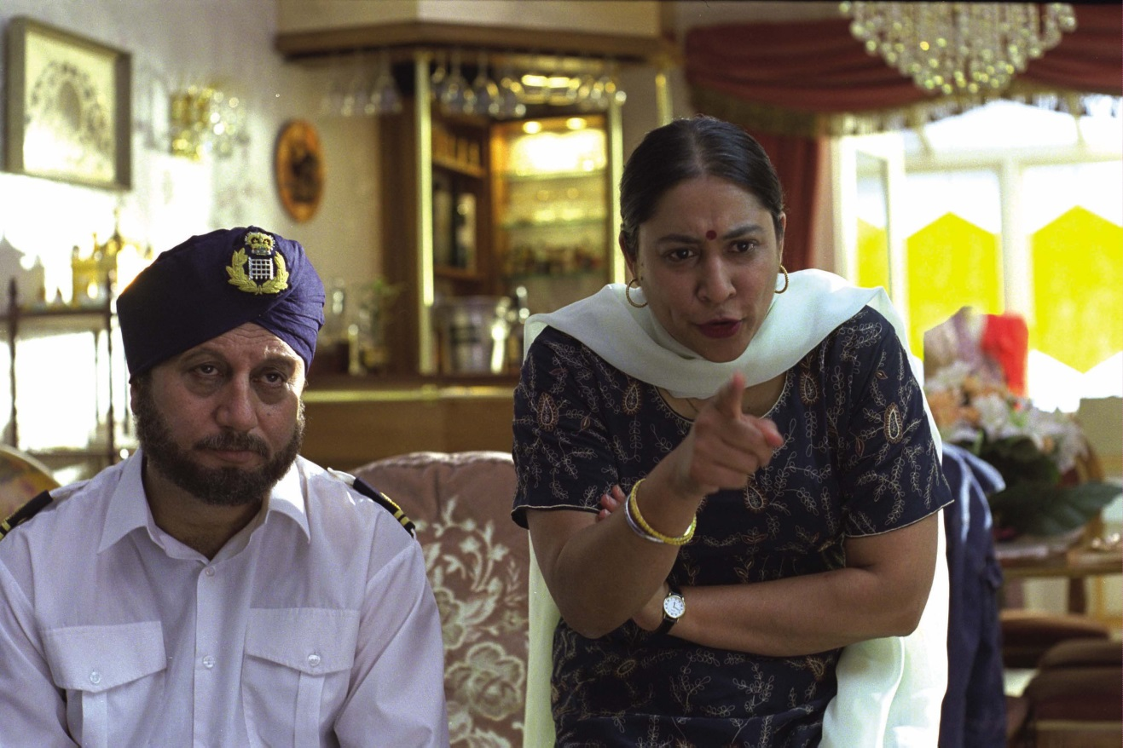

© Moviestore Collection, Ltd / Alamy

Annotations:

---

Part 2 (discussion) – Bend it like Beckham

You have two minutes to prepare for this task.

Proper woman

The stills are taken from the scene when Jess’ mother finds out about her daughter playing football in the park. Back home Jess’ father and mother talk to her. Jess tells her parents that she would like to play football in a women’s team. During this argument Jess father says:

“…You must start behaving like a proper woman…”

Tasks

FIRST explain Mr Bhamra’s statement in the context of the film
- What do you think is a proper woman for him?
- What do you think is a proper woman for Jess?

Give reasons and comment on your partner’s statements.

THEN discuss whether you think Jess’ father is right to say something like that to his daughter.

Give reasons and comment on your partner’s statements.

FINALLY make suggestions how Jess and her father could meet each other halfway in this argument.

Bend it like Beckham: Still ‘Proper woman’ – Pupil A

Inhaltliche Anforderungen
Der Prüfling …
beschreibt das Standbild im Detail, z. B.:
- still from the film Bend it like Beckham
- full shot of Jess playing football with some boys in the park
- setting:
- park
- what / who is shown:
- Jess is playing football with some boys in the park; she has the ball and the boys are after her
- in the background one can see an old building and some trees
- appearance: Jess is wearing her football kit from her training session, the boys are playing only in their trousers or shorts without shirts
- camera operations:
- full shot; eye-level shot
- …
untersucht den Effekt, den das Standbild auf den Zuschauer bzgl. der eingesetzten bildlichen Mittel und ihrer Wirkung auf den Seher hat, z. B.:
- characters: appearance, body language, facial expressions; actions
appearance / body language / facial expression
- Jess is wearing her football kit from her training session while the boys are playing only in their trousers or shorts without shirts in comparison Jess appears more professional than the boys which underlines that she is good at playing football;
Jess takes football seriously and trains hard
- Jess is wearing modern sports gear Jess is athletic; Jess is influenced by
British youth culture
actions
- Jess has the ball and the boys are trying to get it from her Jess is good at
playing football
- camera operations
- full shot, eye-level shot gives a good view of Jess and the constellation of the characters: Jess is athletic and good at football, she can keep up with the boys
- …
entwickelt eine Bildunterschrift, die sich inhaltlich mindestens auf ein Leitthema des Films bezieht, z. B.:
- Jess is playing football in the park with the boys / having fun playing football
- …
erklärt seine Bildunterschrift und somit die generelle Aussage des Standbildes im Kontext der Leitthemen des Films, z. B.:
- Jess is enjoying playing football (themes: e.g. youth culture; women’s football). The boys do not take her seriously at the beginning but Jess can easily keep up with them and therefore contradicts the stereotype that girls cannot play football (themes: e.g. women’s football; stereotypes).
- …

Mögliche Impulse / weiterführende Fragen

Teilaufgabe 1
- Take a closer look at the clothes of the characters.
- Describe the constellation of the characters.
- What are the characters doing?
- Name the camera operations.

Teilaufgabe 2
- How is the viewer’s attention attracted?

Teilaufgabe 3
- What are the main themes of the film?
- How does the still refer to any of the main themes?

Bend it like Beckham: Still ‘Proper woman’ – Pupil B

Inhaltliche Anforderungen
Der Prüfling …
beschreibt das Standbild im Detail, z.B.:
- still from the film BILB
- full shot showing Jess’ parents arguing in their living room
- setting:
- foreground: Mr and Mrs Bhamra
- what / who is shown:
- foreground / centre: father and mother, background: living room and bar
- appearance / body language: Mrs Bhamra is wearing an Indian dress and a white shawl, she is facing and talking to somebody outside the picture (Jess); she is pointing her finger at the person she is talking to; Mr Bhamra is wearing his work uniform and a turban, he has a full beard, he is sitting and is also looking at the person outside the picture
- camera operations:
- medium shot; eye-level shot
- …
untersucht den Effekt, den das Standbild auf den Zuschauer bzgl. der eingesetzten bildlichen Mittel und ihrer Wirkung auf den Seher hat, z. B.:
- characters: appearance, body language, facial expressions; actions
appearance / body language / facial expression
- Mrs Bhamra is pointing at the person she is talking to and staring at this person
Mrs Bhamra is angry and disappointed
- Mr Bhamra is looking at the person, mouth closed sad and disappointed
- Mrs Bhamra is wearing Indian clothes, Mr Bhamra a turban together with his work uniform Mr and Mrs Bhamra represent the Indian values and traditions ...
action
- Mr and Mrs Bhamra are facing somebody, Mrs Bhamra is talking and pointing at this person parents are having a serious talk and are upset about something
- setting
- living room and bar in the background; the setting is a typical British house decorated in the Indian style
- camera operations
- medium shot of Jess’ parents gives a good view of Mr and Mrs Bhamra’s body language and facial expressions,
- eye-level shot viewer gets the impression that Jess’ parents are talking to the viewer, dominance of parents
- …
entwickelt eine Bildunterschrift, die sich inhaltlich mindestens auf ein Leitthema des Films bezieht, z. B.:
- Mr and Mrs Bhamra are telling their daughter off
- …
erklärt seine Bildunterschrift und erklärt so die generelle Aussage des Standbildes im Kontext der Leitthemen des Film, z. B.:
- In this still Jess’ conflict becomes apparent (themes: e.g. youth culture; generational conflict).
- She wants to play football but her parents disagree because in their opinion playing football and dressing in short trousers is not appropriate for an Indian girl (themes: e.g. women’s football; growing up; generational conflicts; traditional/cultural values).
- Mr and Mrs Bhamra represent Jess’ Indian culture and traditions (themes: e.g.
generational conflicts; multicultural Britain; cultural/traditional values).
- …

Mögliche Impulse / weiterführende Fragen

Teilaufgabe 1
- Take a closer look at the clothes of the characters.
- What are the characters doing?
- Describe the setting.
- Name the camera operations.

Teilaufgabe 2
- How is the viewer’s attention attracted?

Teilaufgabe 3
- What are the main themes of the film?
- How does the still refer to any of the main themes?

Bend it like Beckham: Discussion – Proper woman

Inhaltliche Leistung

Inhaltliche Anforderungen
Der Prüfling …

erklärt im Kontext des Films, was Mr Bhamra mit dem Ausdruck ‚proper woman‘ meint und wie sich Jess Auffassung möglicherweise davon unterscheidet und nimmt begründet Stellung zu den Aussagen seines Partners, z. B.:

- I think he refers to a woman living according to traditional Indian values and according to Indian traditions.
- I’m sorry but I can’t agree with you because in my opinion he refers to adult women who study and work.
- Jess probably thinks a proper woman is a woman that follows her dreams and makes her own decisions.
- …

bringt seine Position zum Thema im Kontext des Films klar zum Ausdruck und nennt Argumente, die den Gesprächspartner von seiner Position überzeugen sollen, bzw. stimmt seinem Gesprächspartner begründet zu, z. B.:

- In my opinion Mr Bhamra is not right to say this to his daughter because …
- I think Mr Bhamra is right …
- …

- reasons why Mr Bhamra is not right to say this
- it is her life and she should make her own decisions
- playing football does not mean she does not respect her parents and traditions
- her parents have a very traditional image of her and do not respect her wishes
- …

- reasons why Mr Bhamra is right to say this
- she should respect her parents and her traditions
- her parents are right that she should concentrate on her studies and her career
- …
- …

macht Vorschläge wie Jess und ihr Vater einen Kompromiss in dieser Situation finden könnten und diskutiert diese mit seinem Gesprächspartner, z. B.:

- I would suggest that Jess can play football if she agrees to ...
- Maybe her father could go and watch her play once.
- I’m sorry but I can’t agree with you on this point because ...
- …

Pupil A

Name: __________________________________________________________

Part 1 (individual task): Bend it like Beckham – What’s best for you?
You have 15 minutes to prepare for your individual task.

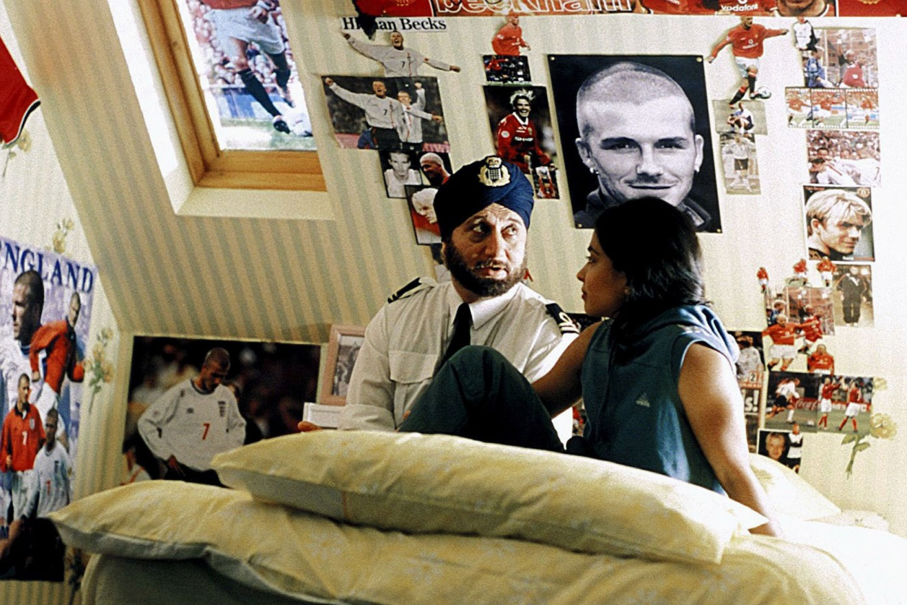

© AF archive / Alamy

Annotations:

---

Pupil B

Name: __________________________________________________________

Part 1 (individual task): Bend it like Beckham – What’s best for you?
You have 15 minutes to prepare for your individual task.

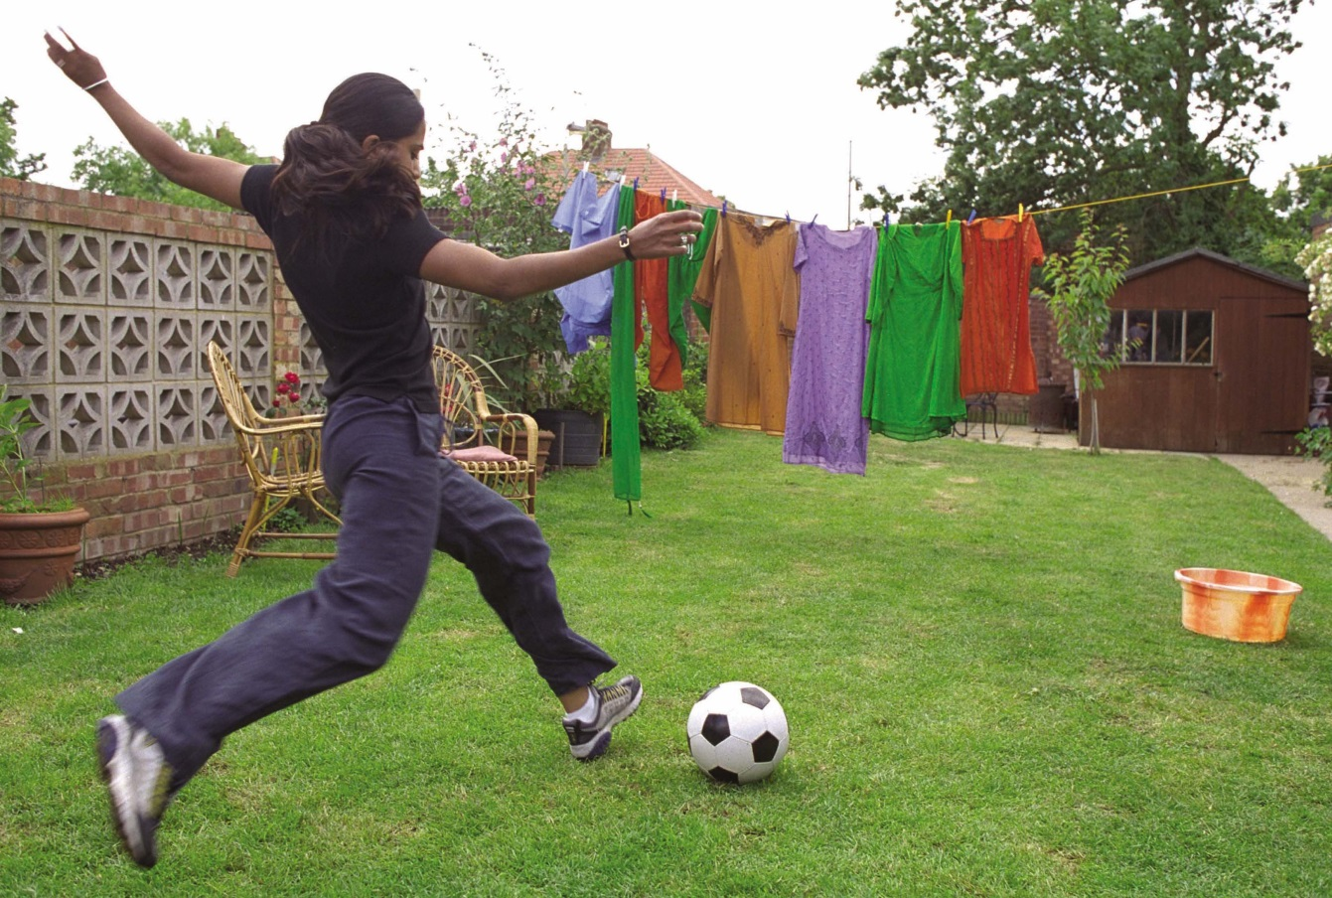

© Moviestore collection Ltd/Alamy

Annotations:

---

Part 2 (discussion) – Bend it like Beckham

You have two minutes to prepare for this task.

Your parents don’t always know what’s best for you

Joe suggests that Jess should ignore her father’s wish that she misses the final game and says:

“Your parents don’t always know what’s best for you, Jess.”

Tasks

FIRST explain in the context of the film what causes Joe to make such a
statement.

Give reasons and comment on your partner’s answer(s).

THEN discuss whether you think Joe is right to make such a statement.
- State your opinion referring to the context of the film.
- Give reasons and comment on your partner’s answer(s).

FINALLY make suggestions how Jess, her family and Joe could meet each other halfway in this situation.

Bend It Like Beckham: Still ‘What’s best for you’ – Pupil A

Inhaltliche Anforderungen
Der Prüfling …
beschreibt das Standbild im Detail, z. B.:
- still from the film Bend it like Beckham
- full shot showing Jess and her father in Jess’ room
- setting:
- Jess’ room
- what / who is shown:
- foreground/centre: Jess and her father sitting on Jess’ bed talking to each other
- background: wall of Jess’ room, decorated with posters showing Beckham in
different situations
- appearance/body language: Mr Bhamra: wearing a turban and a uniform, full beard, sitting next to Jess, looking at her posters; Jess: wearing a track suit, hair in a ponytail, sitting on her bed, facing her father
- camera operations:
- full shot; eye-level shot
- …
untersucht den Effekt, den das Standbild auf den Zuschauer hat bzgl. der eingesetzten bildlichen Mittel und ihrer Wirkung auf den Seher, z. B.:
- characters: appearance, body language and facial expressions; actions
appearance / body language / facial expressions
- Mr Bhamra: wearing a turban and his uniform represents traditional Indian lifestyle (turban) and his everyday life (working at the airport)
- Mr Bhamra: open mouth, looking at the posters sad look, earnest conversation with Jess, is concerned
- Jess: wearing tracksuit Jess is athletic, influenced by British youth culture and represents the younger generation
- Jess is facing her father listening attentively
actions
- Jess and her father sitting on Jess’ bed and talking to each other intimate
situation, they trust each other
- setting
- Jess’ room with posters of Beckham fan of Beckham, likes football
- camera operations
- full shot showing Jess and her father in Jess’ room gives a good view of the characters and their feelings; shows the constellation of the characters
- eye-level shot viewer gets the impression of being in Jess’ room with the
characters
- …
entwickelt eine Bildunterschrift, die sich inhaltlich mindestens auf ein Leitthema des Films bezieht, z. B.:
- Jess and her father are having a serious talk
- …
erklärt seine Bildunterschrift und erklärt so die generelle Aussage des Standbildes im Kontext der Leitthemen des Film, z. B.:
- Jess’ father is concerned about Jess’ interest in football and playing football herself, he thinks it is not appropriate for a young woman (themes: e.g. women’s football;
stereotypes). Mr Bhamra represents the older generation and Indian traditions, while Jess represents a younger Indian generation that is aware of their roots but has also adopted modern lifestyles (themes: e.g. multicultural Britain; cultural values/traditions; tradition vs. modernism).
- …

Mögliche Impulse / weiterführende Fragen

Teilaufgabe 1
- Take a closer look at the clothes of the characters.
- Describe the constellation of the characters.
- What are the characters doing?
- Name the camera operations.

Teilaufgabe 2
- How is the viewer’s attention attracted?

Teilaufgabe 3
- What are the main themes of the film?
- How does the still refer to any of the main themes?

Bend It Like Beckham: Still ‘What’s best for you’ – Pupil B

Inhaltliche Anforderungen
Der Prüfling …
beschreibt das Standbild im Detail, z. B.:
- still from the film Bend it like Beckham
- full shot showing Jess in the garden kicking a ball
- setting:
- the Bhamra’s backyard: washing hanging on the clothes line, little garden shed
- what / who is shown:
- foreground: Jess kicking a football towards the washing on the clothes line;
- in the middle: the washing on the clothes line; the washing is colourful, traditional Indian clothes
- appearance: Jess is shown from the back; wearing a tracksuit and trainers, hair in a ponytail
- camera operations:
- full shot; eye-level shot
- …
untersucht den Effekt, den das Standbild auf den Zuschauer hat bzgl. der eingesetzten bildlichen Mittel und ihrer Wirkung auf den Seher, z. B.:
- characters: appearance, body language and facial expressions; actions
appearance / body language / facial expression
- Jess is wearing a tracksuit and trainers she is athletic
actions
- Jess is kicking a football towards the washing on the clothes line the clothes appear like a defensive wall in football
- setting
- backyard with washing the setting is a typical British backyard
- traditional Indian clothes in a typical British backyard, Jess wearing tracksuit and trainers and kicking a ball contrast of Jess’ Indian roots and her interest in football, she tries to bend the ball like Beckham; the clothes appear like a defensive wall in football shows Jess’ conflict about arranging her life between her Indian roots and her interest in football, and becoming a professional football player
- camera operations
- full shot showing Jess kicking the ball gives a good view of Jess and her
environment and shows her talent
- eye-level shot viewer gets the impression of being with Jess in the backyard
- …
entwickelt eine Bildunterschrift, die sich inhaltlich mindestens auf ein Leitthema des Films bezieht, z. B.:
- Jess is bending the ball like Beckham
- …
erklärt seine Bildunterschrift und erklärt so die generelle Aussage des Standbildes im Kontext der Leitthemen des Film, z. B.:
- The still shows the conflict Jess is in. On the one hand she respects her culture and traditions and is a good daughter who helps with the domestic chores (themes: e.g. multicultural Britain; cultural traditions/values); on the other hand she tries to bend the ball like Beckham (themes: women’s football; tradition vs. modernism). She is kicking the football towards the washing on the clothes line. The clothes appear like a defensive wall (themes: generational conflicts; tradition vs. modernism)
- ...

Mögliche Impulse / weiterführende Fragen

Teilaufgabe 1
- Take a closer look at the clothes of the characters.
- What are the characters doing?
- Describe the setting.
- Name the camera operations.

Teilaufgabe 2
- How is the viewer’s attention attracted?

Teilaufgabe 3
- What are the main themes of the film?
- How does the still refer to any of the main themes?

Bend It Like Beckham: Discussion – Your parents don’t always know what’s best for you

Inhaltliche Leistung

Inhaltliche Anforderungen
Der Prüfling …
erklärt die Bedeutung des Zitats das Zitat im Kontext des Films und nimmt begründet Stellung zu den Aussagen seines Partners, z. B.

- In my opinion Joe says this because Jess has not shown up for football training and he really cares for Jess and wants her to realise her dream to play football professionally.
- I agree with you because ... but I also think that ...
- ...

bringt seine Position zum Thema im Kontext des Films klar zum Ausdruck und nennt Argumente, die den Gesprächspartner von seiner Position überzeugen sollen, bzw. stimmt seinem Gesprächspartner begründet zu, z. B.:

- In my opinion Joe is right to say this because ...
- In my opinion Joe is not right to say this because …
- ...

- reasons why Joe is right to say this
- a football scout is present at the game and this is Jess’ only chance to get a scholarship at an American university
- Jess needs a good friend who takes a different position than her parents and thereby supports her in her dreams
- …

- reasons why Joe is not right to say this
- it is Pinky’s wedding and it is Jess’ duty to be at her sister’s side at a day like this.
- Jess’ parents do not allow her to play football
- …

- Finally I think we can agree that…
- …

macht Vorschläge wie Jess, ihre Familie und Joe einen Kompromiss finden könnten und diskutiert diese mit seinem Gesprächspartner, z. B.:

- I would suggest that Jess can play football if she agrees to ...
- Maybe Joe could offer to ...
- Maybe her family could go and watch Jess play football to get an impression of her talent.
- I’m sorry but I can’t agree with you on this point because ...
- …

Chadha, Gurinder. Bend it like Beckham. Highlight Film, 2002.
Kernlehrplan SI. Gymnasium. Englisch (G8), S. 39,… Gesamtschule. Englisch, S. 42, … Realschule. Englisch, S. 36, … Hauptschule. Englisch, S. 30, … Abendrealschule. Englisch, S. 18
Ebd.
Ebd. S. 36 und 42, Ebd. S. 38 und 47, Ebd. S. 35 und 39, Ebd. S. 28 und 32, Ebd. S. 17 und 22

